C:\Users\abc\Desktop\Priyanka\Paper\paper_1\manuscript\Final_Paper_1\Final_version2\FINAL_20_12_17\23_12_2017\NAR\BMC_biology\Plos_biology\biophysical\revised_BJ\New folder\Final_submission\Figure_1.tiff

**Supplementary figure S1:** **Structural and energy profiles of 1001 nucleotides long sequences having primary promoters (green line) and coding sequences (red line).** Sequences, having primary promoters, (12880) were lined up with TSS at the same position (“0”), extending 500 nucleotides on both sides. Likewise all CDSs (6281) were also superimposed.Ordinate represents the numeric value of that parameter, while abscissa represents the nucleotide position**.**

**Supplementary Figure S2**-**(1-31).** Comparative profiles of twelve selected organisms for each of the 31 parameters (S2-1 to S2-28 represents structural parameters while S2-29 to S2-31 represent energy parameters); green line represents the pooled primary promoters of that organisms while red line represents the corresponding CDS regions (for total number of promoters and CDS of each organism see Table 1). Both types of sequences are 1001 nucleotides long, promoters extending from -500 to +500 with respect to TSS at 0. The ordinate represents the numeric value of that parameter obtained by superimposing all the promoter sequences with TSS at the same position as well as all CDSs for that organism, while abscissa represents the nucleotide position.

**S2-1 (X - Displacement )**

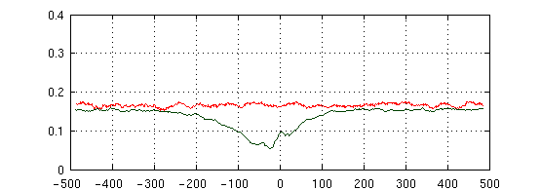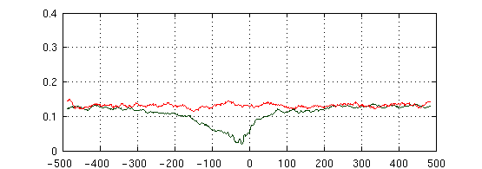

***Bacillusamamyloliquefaciens***

***Chlamydia pneumonia CWL029***

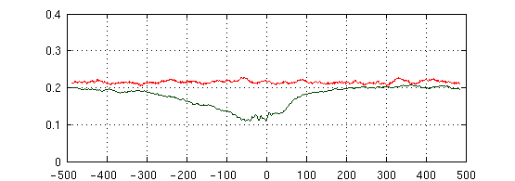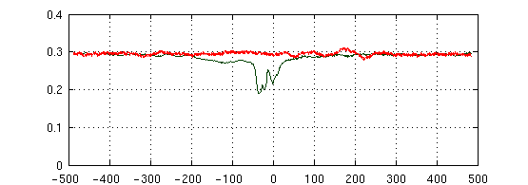

***Escherichi coli***

***Halofrex volcanii***

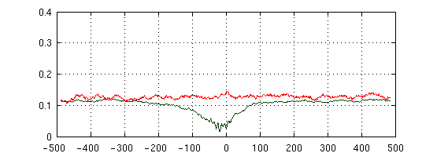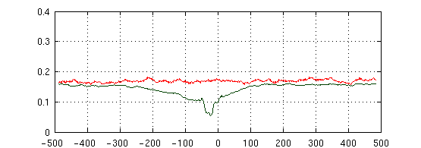

***Helicobacterpylorii***

***Methanolobus psychrophilus***

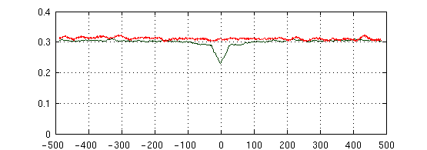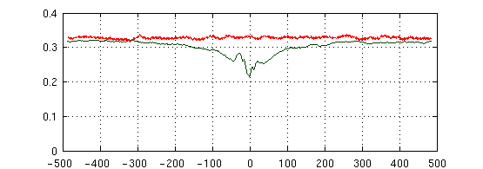

***Mycobacterium tuberculosis H37Rv***

***Pseudomonas aeruginosa PA14***

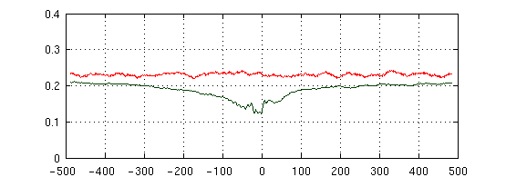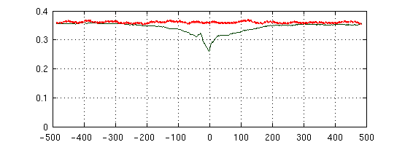

***Salmonella typhimurium***

***Streptomyces coelicolor A3***

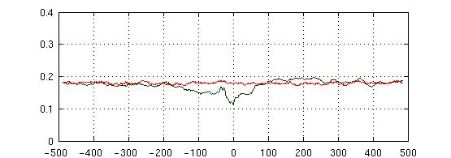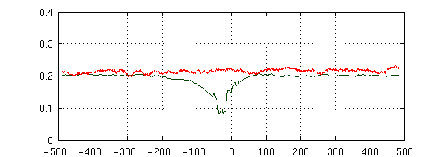

***Synechocystis sp. PCC6803***

***Thermococcus kodakarensis***

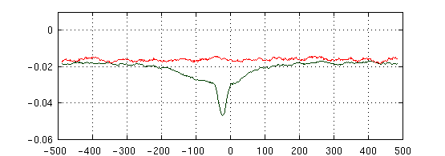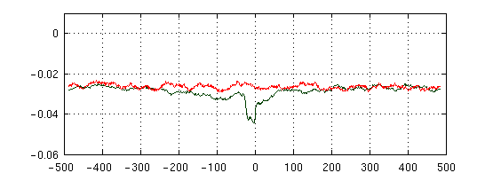

***Bacillus amyloliquefaciens***

***Chlamydia pneumonia CWL029***

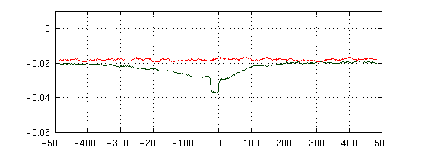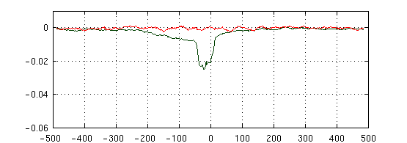

***Escherichia coli***

***Halofrex volcanii***

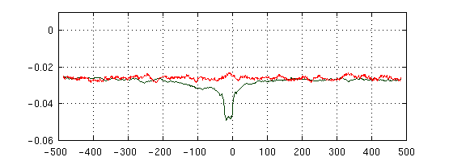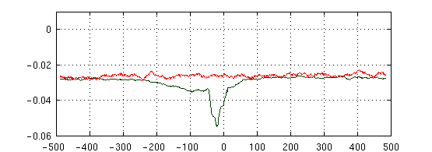

***Helicobacter pylori***

***Methanolobus psychrophilus***

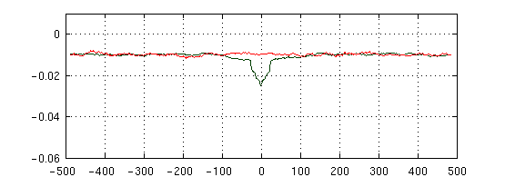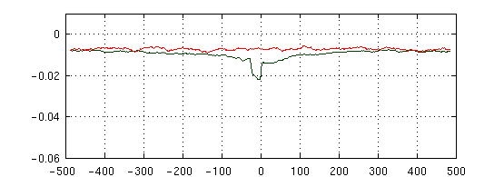

***Mycobacterium tuberculosis H37Rv***

***Pseudomonas aeruginosa PA14***

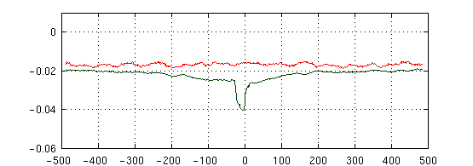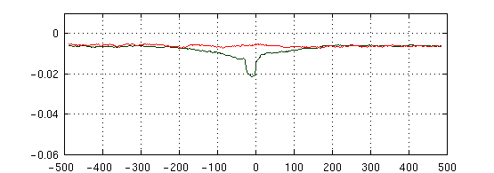

***Salmonella typhimurium***

***Streptomyces coelicolor A3***

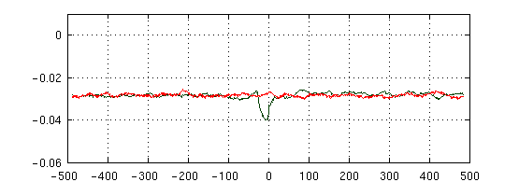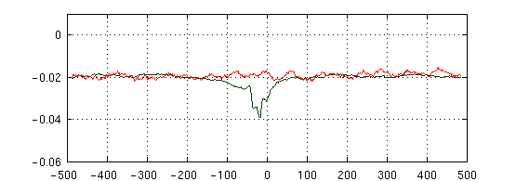

***Synechocystis sp. PCC6803***

***Thermococcus kodakarensis***

**S2-2 (Y - Displacement)**

***Bacillus amyloliquefaciens***

***Chlamydia pneumonia CWL029***

***Escherichia coli***

***Halofrex volcanii***

***Helicobacter pylori***

***Methanolobus psychrophilus***

***Mycobacterium tuberculosis H37Rv***

***Pseudomonas aeruginosa PA14***

***Salmonella typhimurium***

***Streptomyces coelicolor A3***

***Synechocystis sp. PCC6803***

***Thermococcus kodakarensis***

**S2-3 (Inclination)**

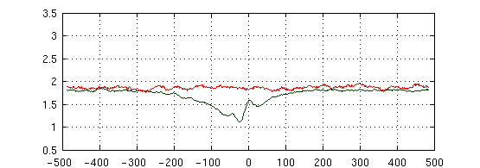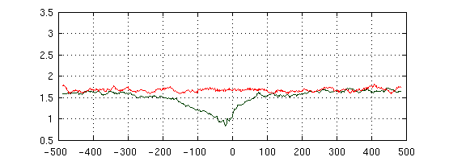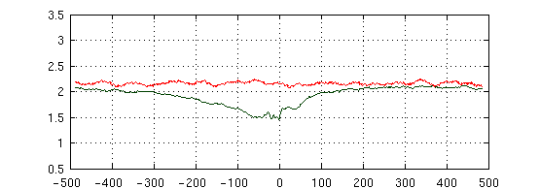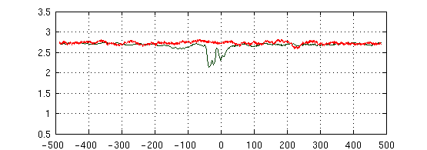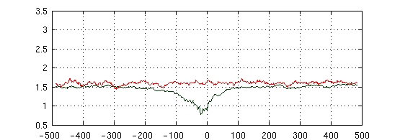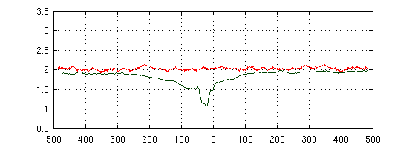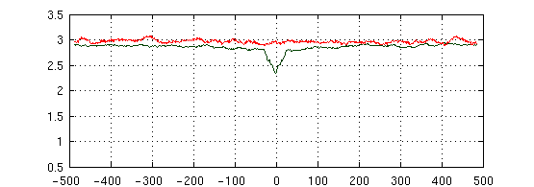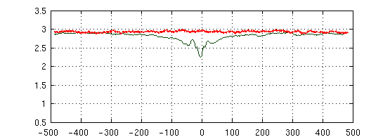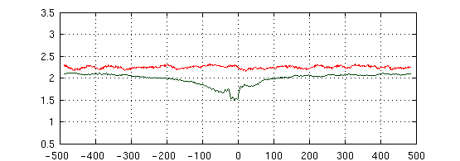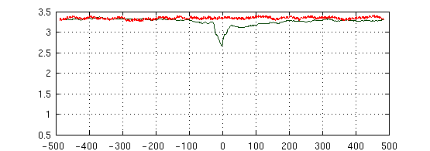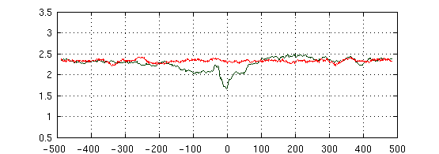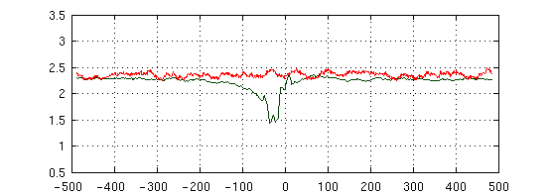

***Bacillus amyloliquefaciens***

***Chlamydia pneumonia CWL029***

***Escherichia coli***

***Halofrex volcanii***

***Helicobacter pylori***

***Methanolobus psychrophilus***

***Mycobacterium tuberculosis H37Rv***

***Pseudomonas aeruginosa PA14***

***Salmonella typhimurium***

***Streptomyces coelicolor A3***

***Synechocystis sp. PCC6803***

***Thermococcus kodakarensis***

**S2-4 (Tip)**

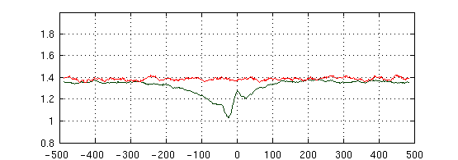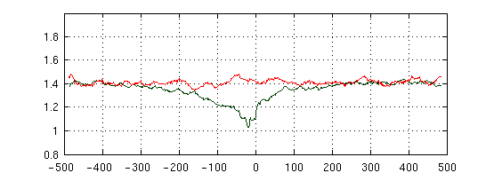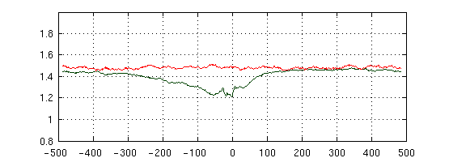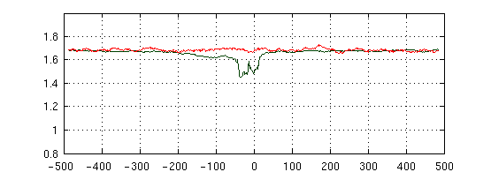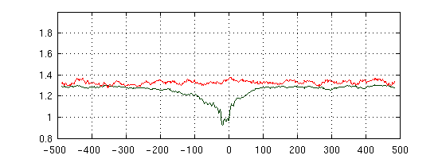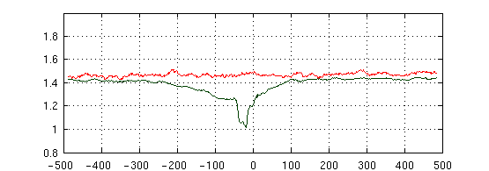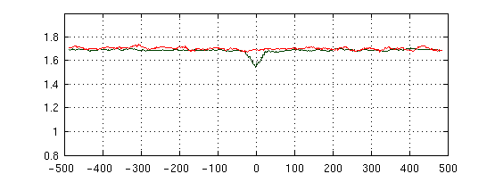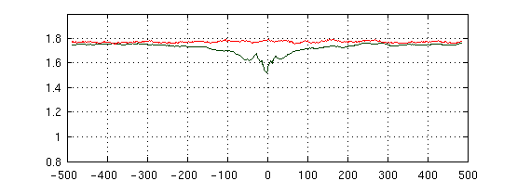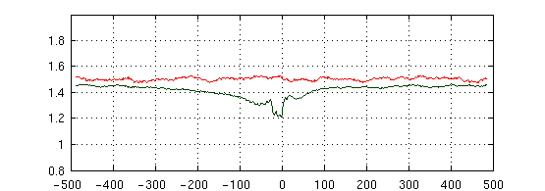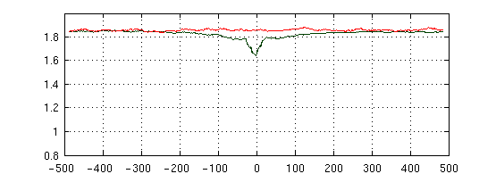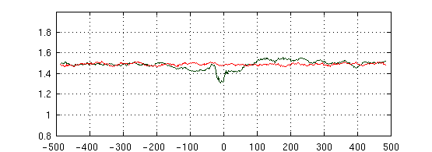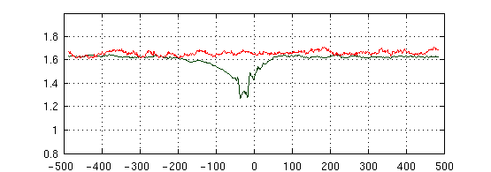

***Bacillus amyloliquefaciens***

***Chlamydia pneumonia CWL029***

***Escherichia coli***

***Halofrex volcanii***

***Helicobacter pylori***

***Methanolobus psychrophilus***

***Mycobacterium tuberculosis H37Rv***

***Pseudomonas aeruginosa PA14***

***Salmonella typhimurium***

***Streptomyces coelicolor A3***

***Synechocystis sp. PCC6803***

***Thermococcus kodakarensis***

**S2-5 (Axis-Bend)**

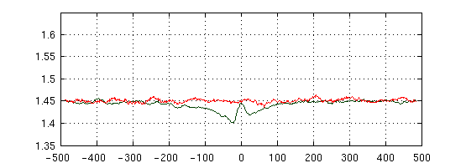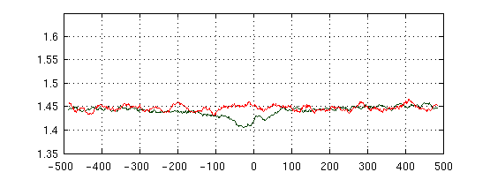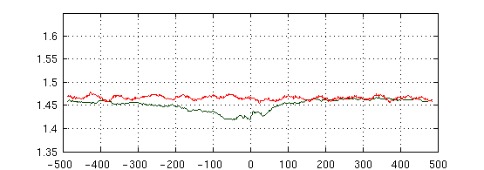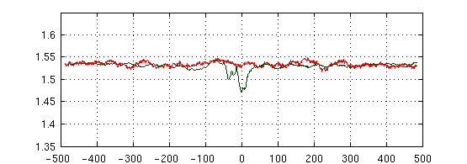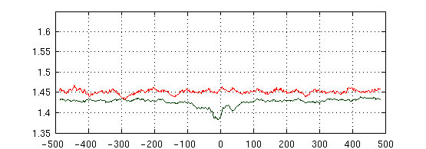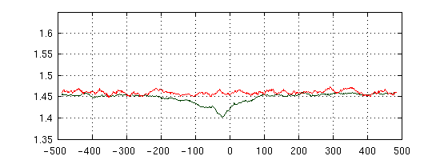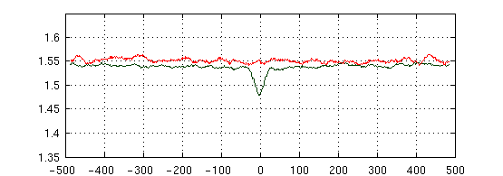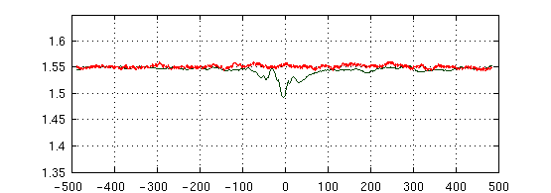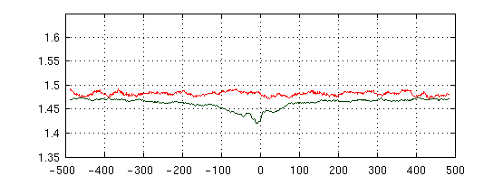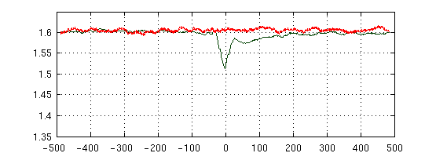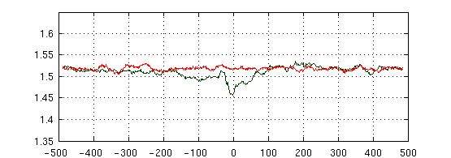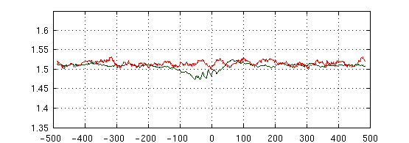

***Bacillus amyloliquefaciens***

***Chlamydia pneumonia CWL029***

***Escherichia coli***

***Halofrex volcanii***

***Helicobacter pylori***

***Methanolobus psychrophilus***

***Mycobacterium tuberculosis H37Rv***

***Pseudomonas aeruginosa PA14***

***Salmonella typhimurium***

***Streptomyces coelicolor A3***

***Synechocystis sp. PCC6803***

***Thermococcus kodakarensis***

**S2-6 (Shear)**

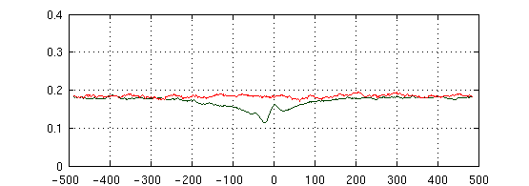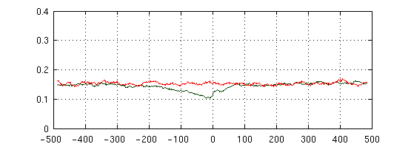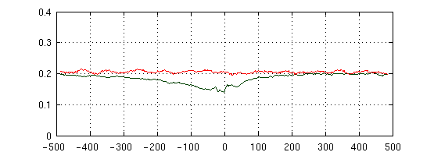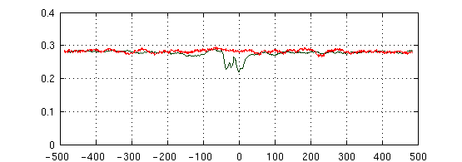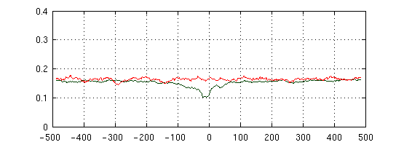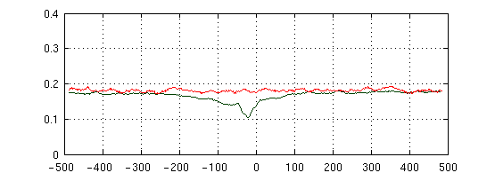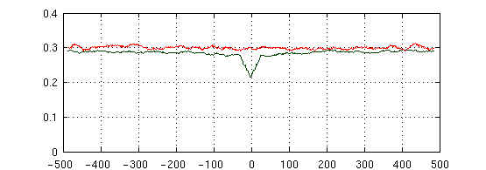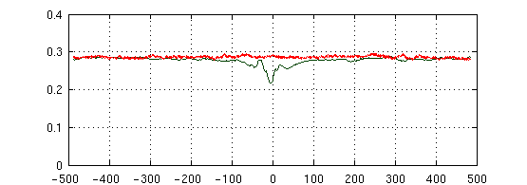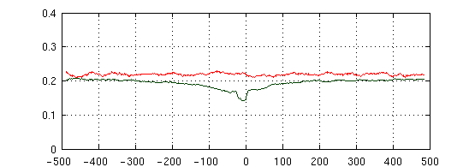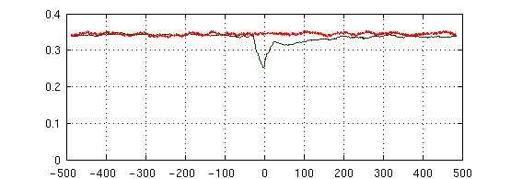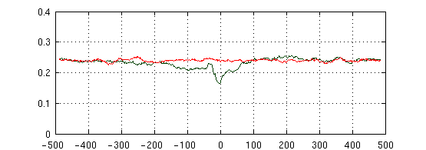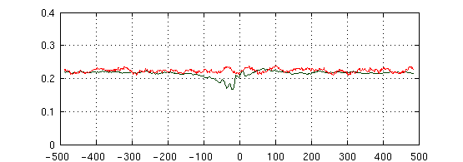

***Bacillus amyloliquefaciens***

***Chlamydia pneumonia CWL029***

***Escherichia coli***

***Halofrex volcanii***

***Helicobacter pylori***

***Methanolobus psychrophilus***

***Mycobacterium tuberculosis H37Rv***

***Pseudomonas aeruginosa PA14***

***Salmonella typhimurium***

***Streptomyces coelicolor A3***

***Synechocystis sp. PCC6803***

***Thermococcus kodakarensis***

**S2-7 (Stretch)**

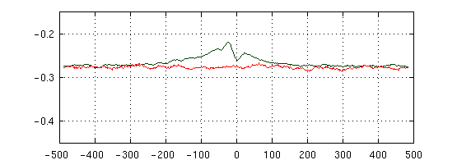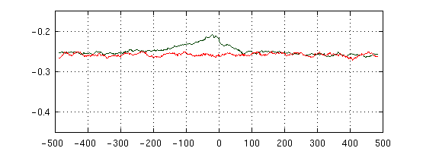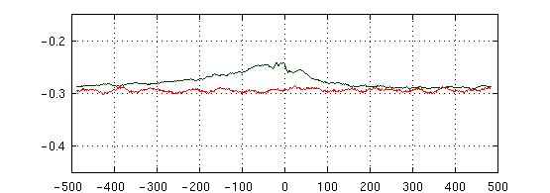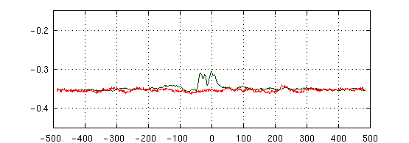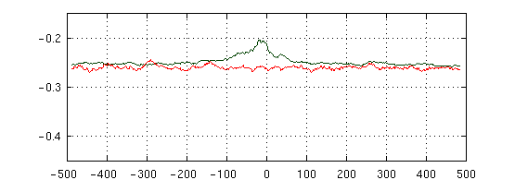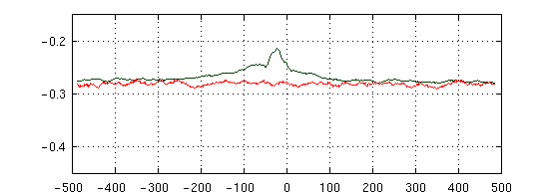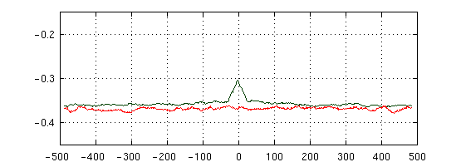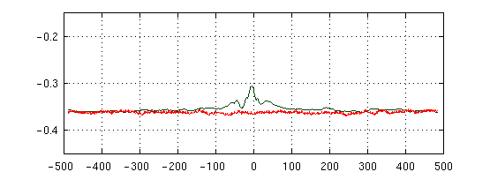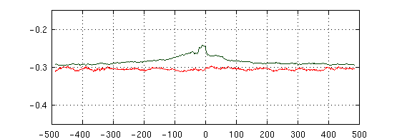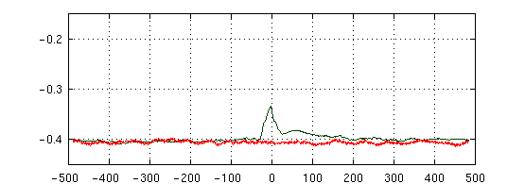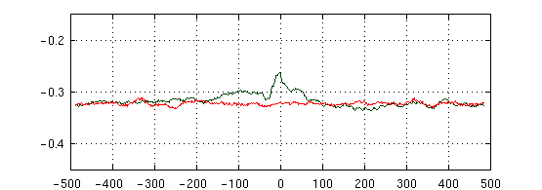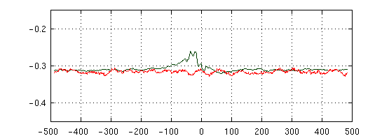

***Bacillus amyloliquefaciens***

***Chlamydia pneumonia CWL029***

***Escherichia coli***

***Halofrex volcanii***

***Helicobacter pylori***

***Methanolobus psychrophilus***

***Mycobacterium tuberculosis H37Rv***

***Pseudomonas aeruginosa PA14***

***Salmonella typhimurium***

***Streptomyces coelicolor A3***

***Synechocystis sp. PCC6803***

***Thermococcus kodakarensis***

**S2-8 (Stagger)**

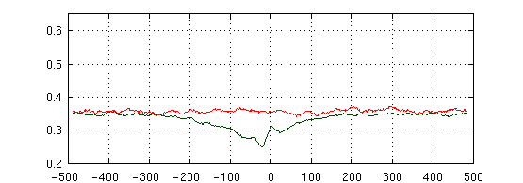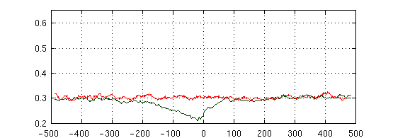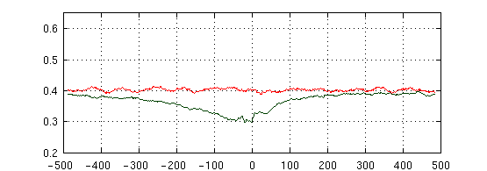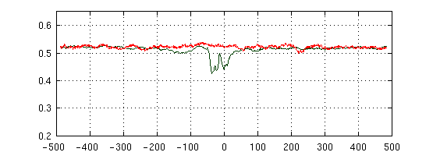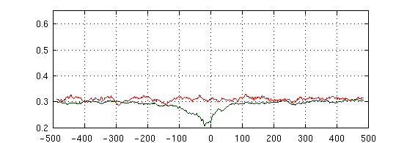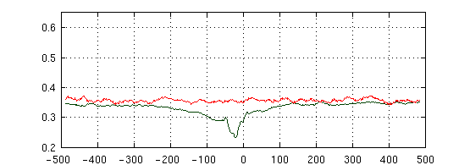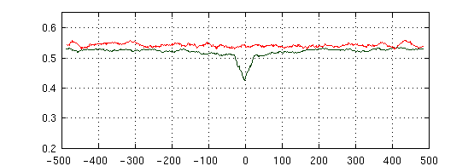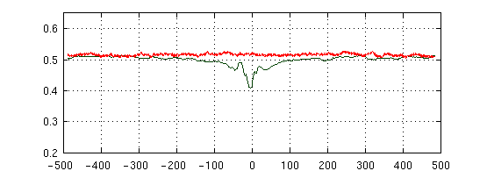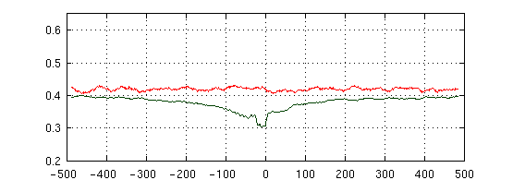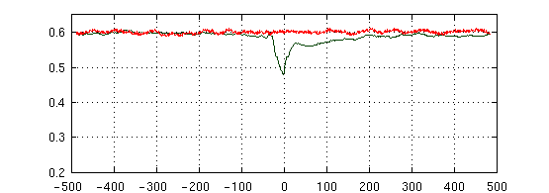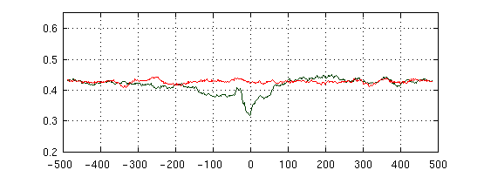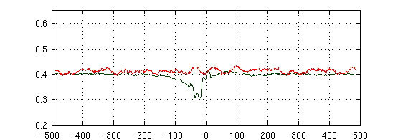

***Bacillus amyloliquefaciens***

***Chlamydia pneumonia CWL029***

***Escherichia coli***

***Halofrex volcanii***

***Helicobacter pylori***

***Methanolobus psychrophilus***

***Mycobacterium tuberculosis H37Rv***

***Pseudomonas aeruginosa PA14***

***Salmonella typhimurium***

***Streptomyces coelicolor A3***

***Synechocystis sp. PCC6803***

***Thermococcus kodakarensis***

**S2-9 (Buckle)**

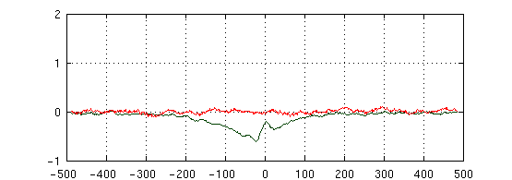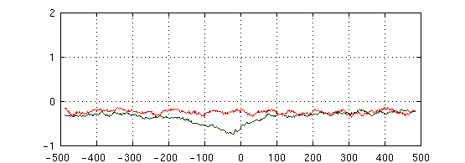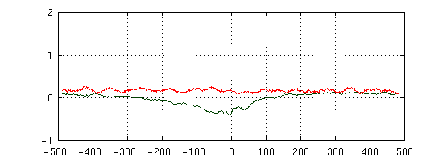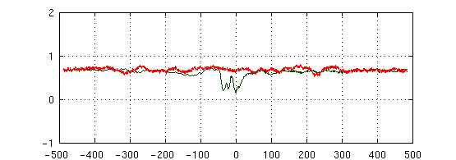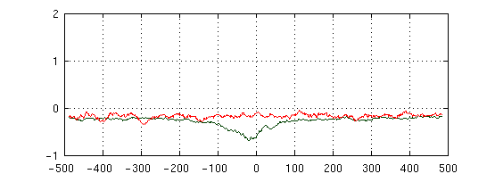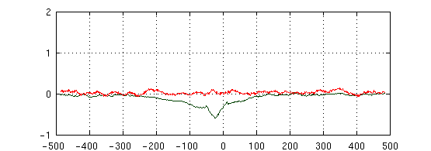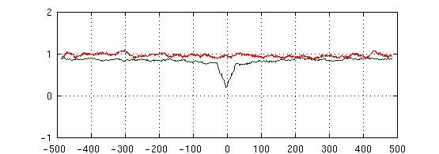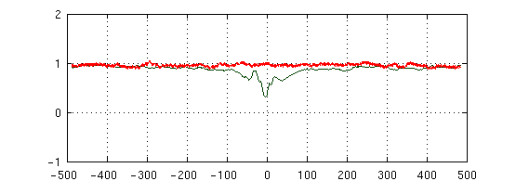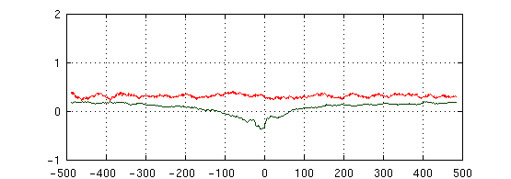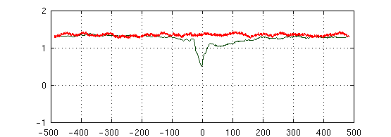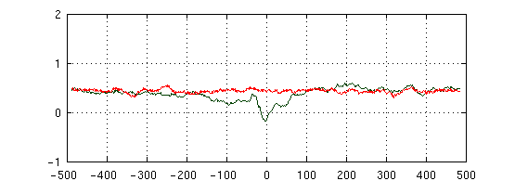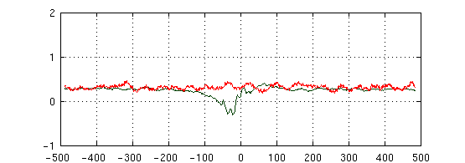

***Bacillus amyloliquefaciens***

***Chlamydia pneumonia CWL029***

***Escherichia coli***

***Halofrex volcanii***

***Helicobacter pylori***

***Methanolobus psychrophilus***

***Mycobacterium tuberculosis H37Rv***

***Pseudomonas aeruginosa PA14***

***Salmonella typhimurium***

***Streptomyces coelicolor A3***

***Synechocystis sp. PCC6803***

***Thermococcus kodakarensis***

**S2-10 (Propeller twist**

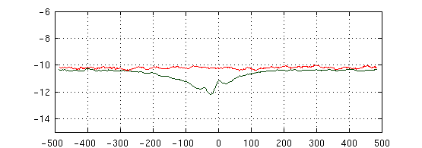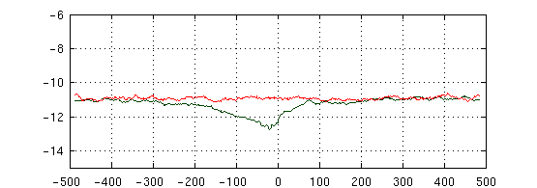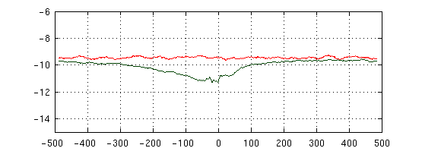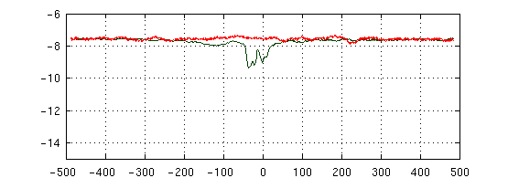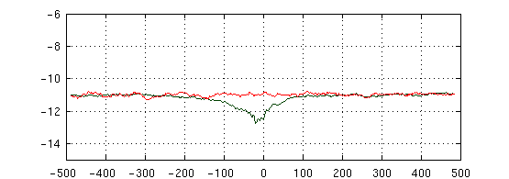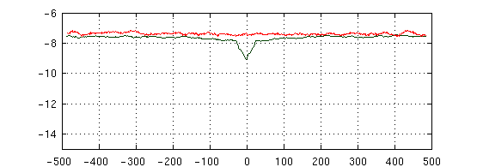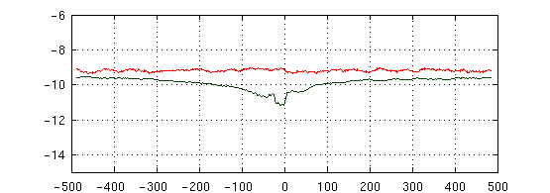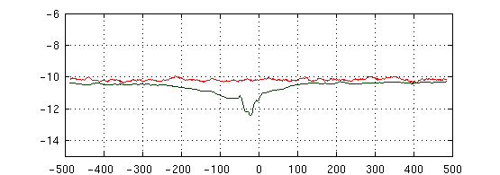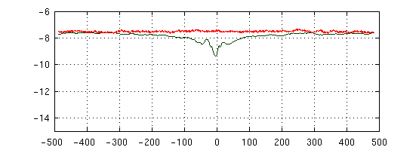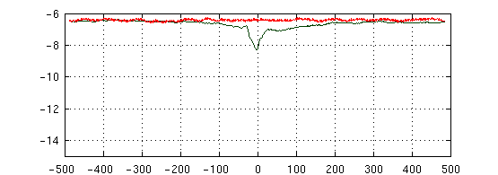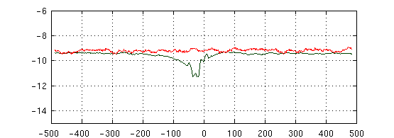

***Bacillus amyloliquefaciens***

***Chlamydia pneumonia CWL029***

***Escherichia coli***

***Halofrex volcanii***

***Helicobacter pylori***

***Methanolobus psychrophilus***

***Mycobacterium tuberculosis H37Rv***

***Pseudomonas aeruginosa PA14***

***Salmonella typhimurium***

***Streptomyces coelicolor A3***

***Synechocystis sp. PCC6803***

***Thermococcus kodakarensis***

**S2-11 (Opening)**

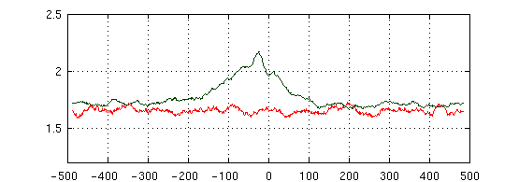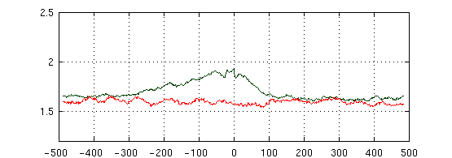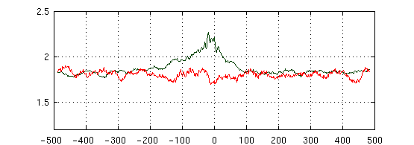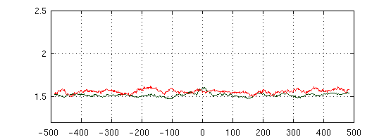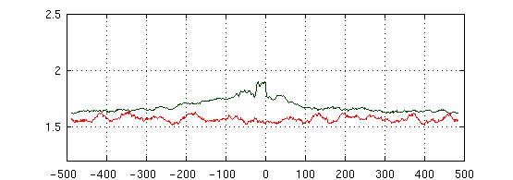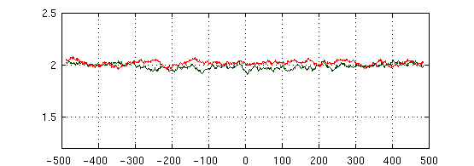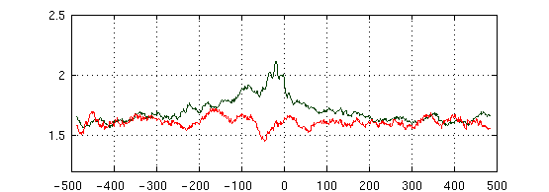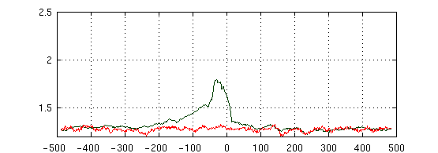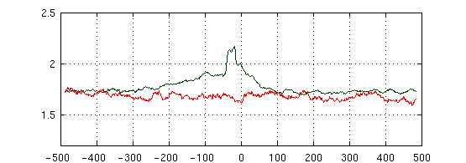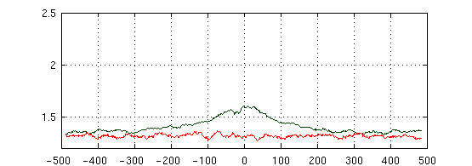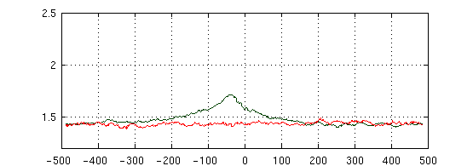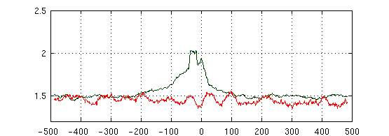

***Bacillus amyloliquefaciens***

***Chlamydia pneumonia CWL029***

***Escherichia coli***

***Halofrex volcanii***

***Helicobacter pylori***

***Methanolobus psychrophilus***

***Mycobacterium tuberculosis H37Rv***

***Pseudomonas aeruginosa PA14***

***Salmonella typhimurium***

***Streptomyces coelicolor A3***

***Synechocystis sp. PCC6803***

***Thermococcus kodakarensis***

**S2-12 (Shift)**

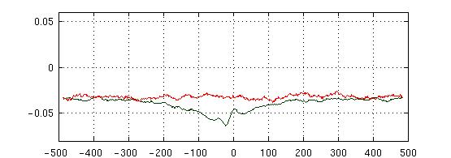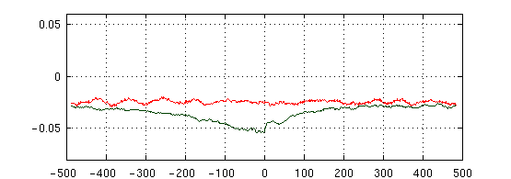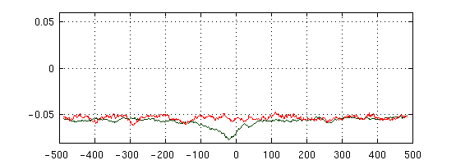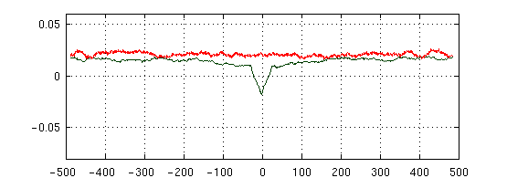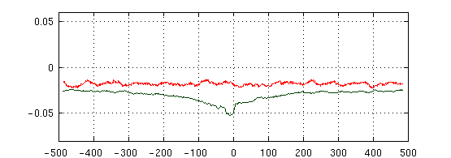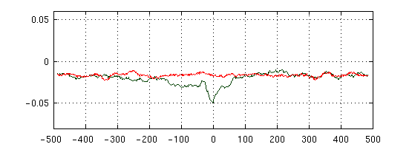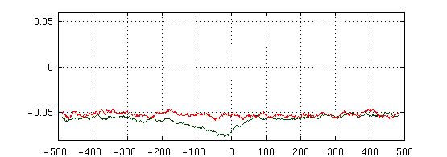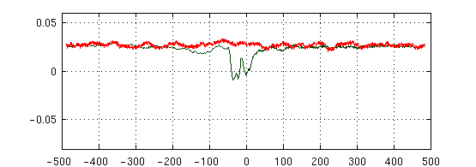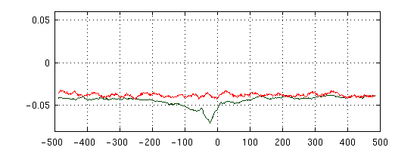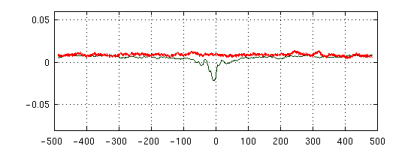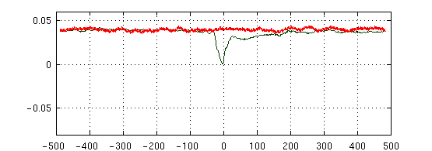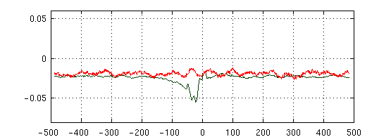

***Bacillus amyloliquefaciens***

***Chlamydia pneumonia CWL029***

***Escherichia coli***

***Halofrex volcanii***

***Helicobacter pylori***

***Methanolobus psychrophilus***

***Mycobacterium tuberculosis H37Rv***

***Pseudomonas aeruginosa PA14***

***Salmonella typhimurium***

***Streptomyces coelicolor A3***

***Synechocystis sp. PCC6803***

***Thermococcus kodakarensis***

**S2-13 (Slide)**

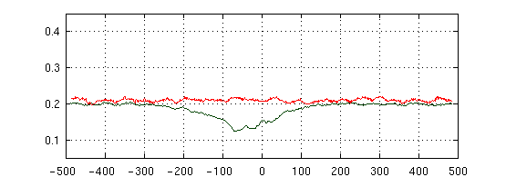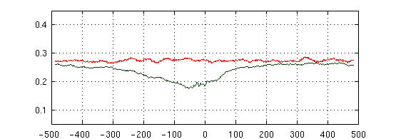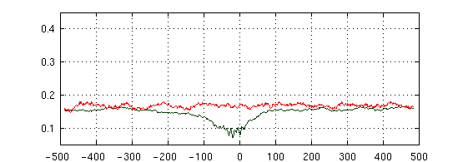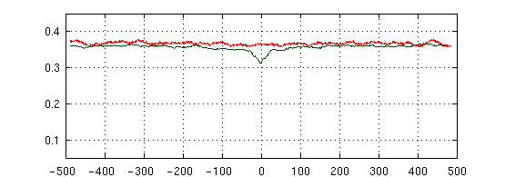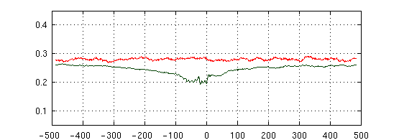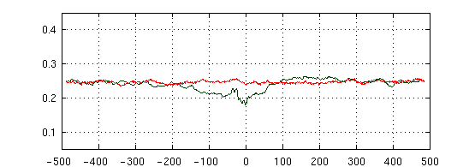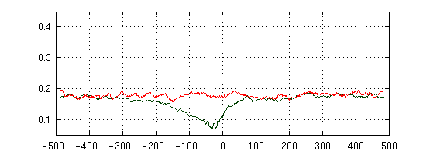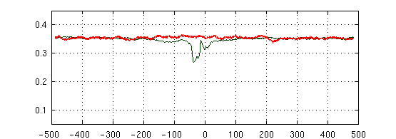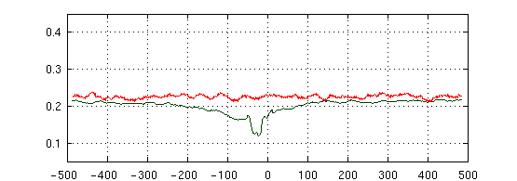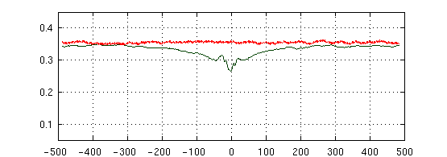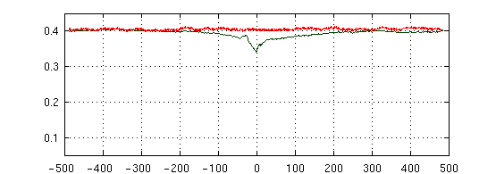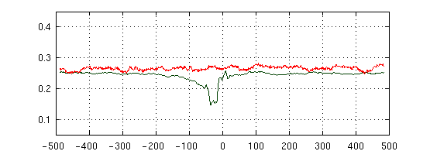

***Bacillus amyloliquefaciens***

***Chlamydia pneumonia CWL029***

***Escherichia coli***

***Halofrex volcanii***

***Helicobacter pylori***

***Methanolobus psychrophilus***

***Mycobacterium tuberculosis H37Rv***

***Pseudomonas aeruginosa PA14***

***Salmonella typhimurium***

***Streptomyces coelicolor A3***

***Synechocystis sp. PCC6803***

***Thermococcus kodakarensis***

**S2-14 (Rise)**

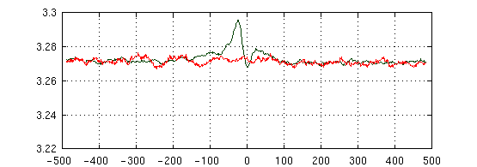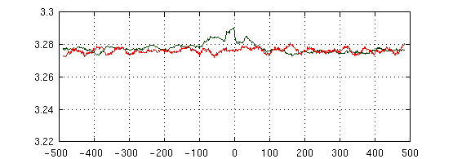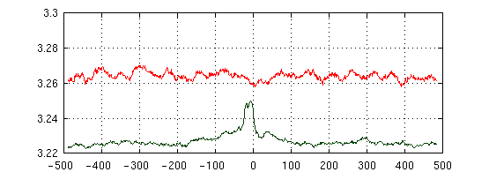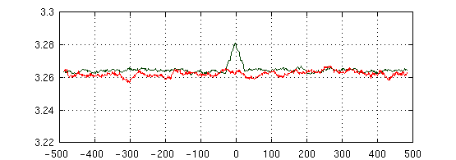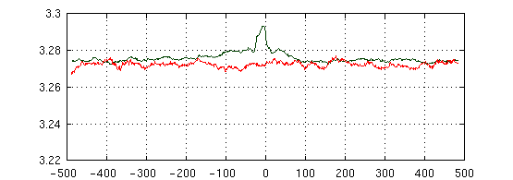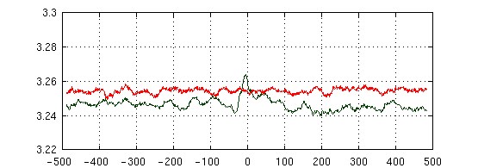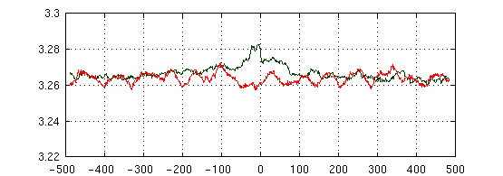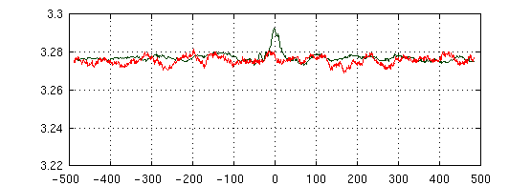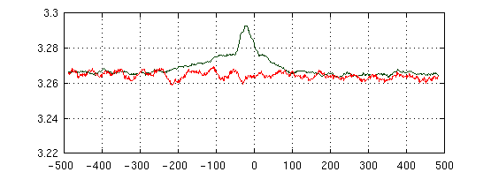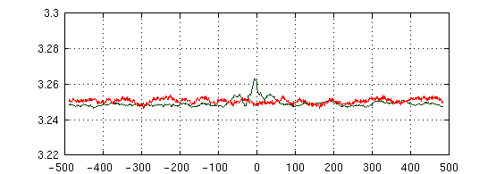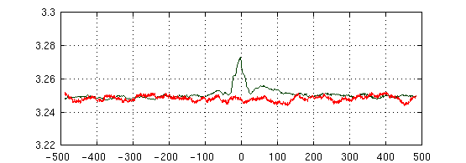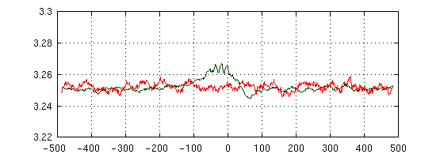

***Bacillus amyloliquefaciens***

***Chlamydia pneumonia CWL029***

***Escherichia coli***

***Halofrex volcanii***

***Helicobacter pylori***

***Methanolobus psychrophilus***

***Mycobacterium tuberculosis H37Rv***

***Pseudomonas aeruginosa PA14***

***Salmonella typhimurium***

***Streptomyces coelicolor A3***

***Synechocystis sp. PCC6803***

***Thermococcus kodakarensis***

**S2-15 (Tilt)**

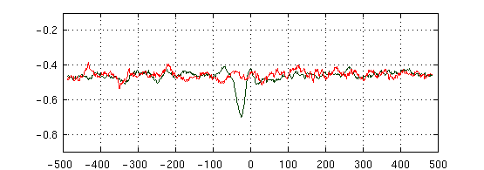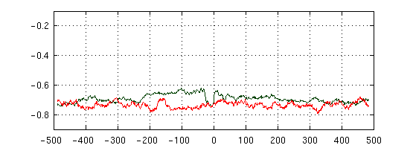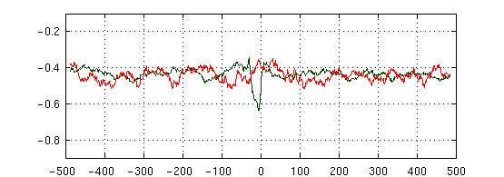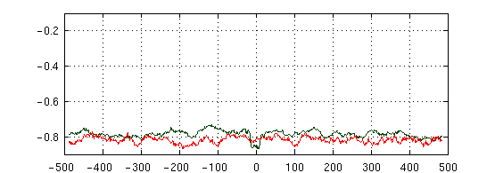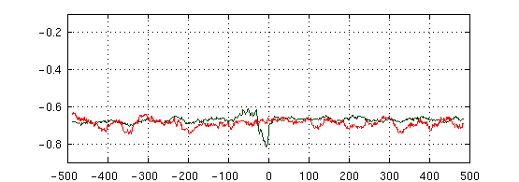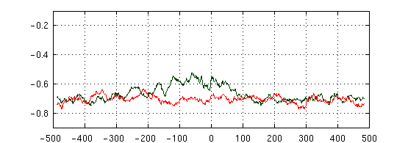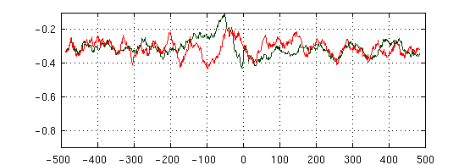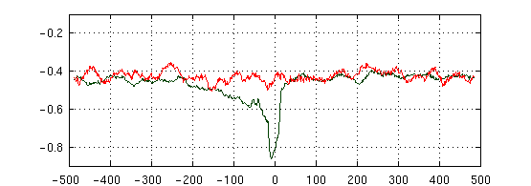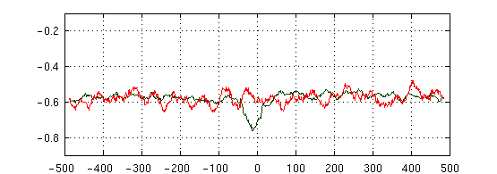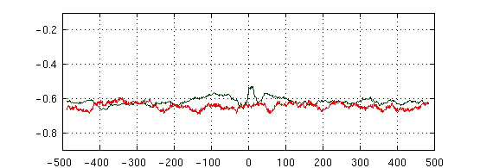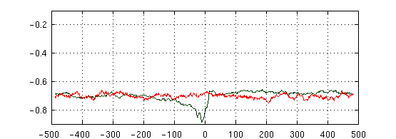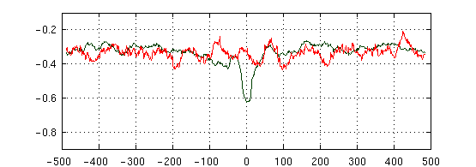

***Bacillus amyloliquefaciens***

***Chlamydia pneumonia CWL029***

***Escherichia coli***

***Halofrex volcanii***

***Helicobacter pylori***

***Methanolobus psychrophilus***

***Mycobacterium tuberculosis H37Rv***

***Pseudomonas aeruginosa PA14***

***Salmonella typhimurium***

***Streptomyces coelicolor A3***

***Synechocystis sp. PCC6803***

***Thermococcus kodakarensis***

**S2-16 (Roll)**

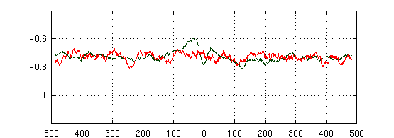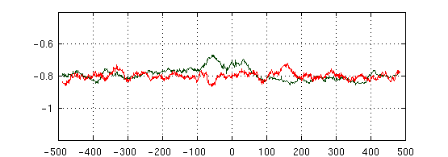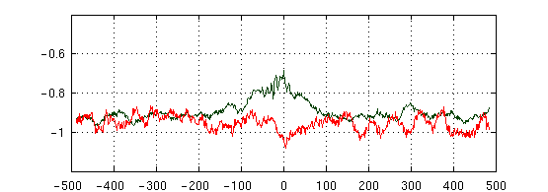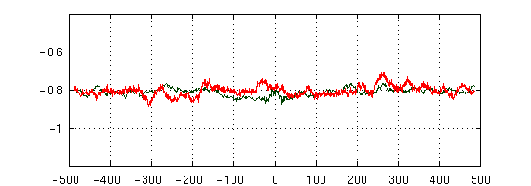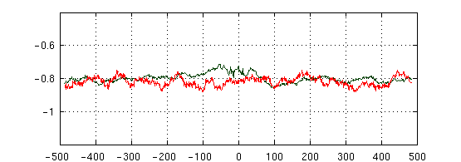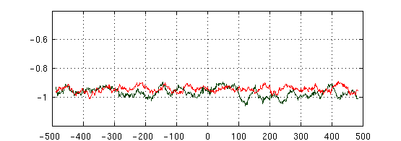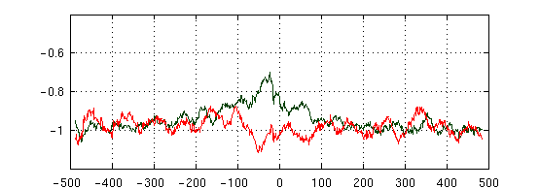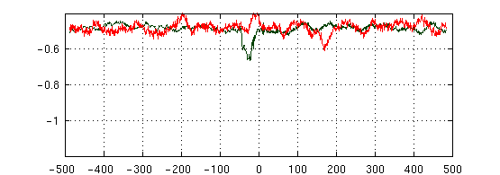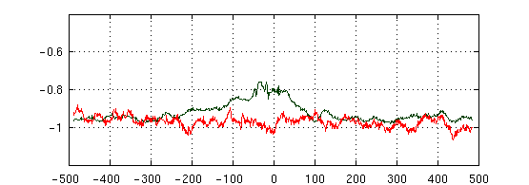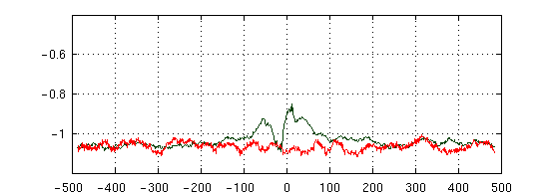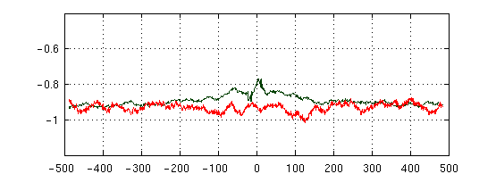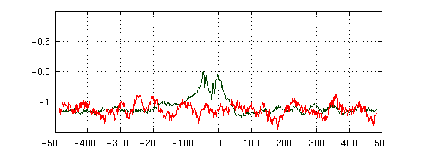

***Bacillus amyloliquefaciens***

***Chlamydia pneumonia CWL029***

***Escherichia coli***

***Halofrex volcanii***

***Helicobacter pylori***

***Methanolobus psychrophilus***

***Mycobacterium tuberculosis H37Rv***

***Pseudomonas aeruginosa PA14***

***Salmonella typhimurium***

***Streptomyces coelicolor A3***

***Synechocystis sp. PCC6803***

***Thermococcus kodakarensis***

**S2-17 (Twist)**

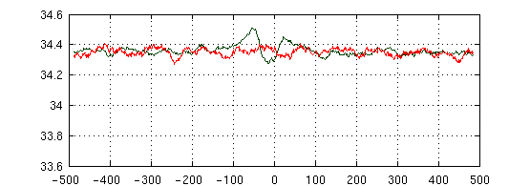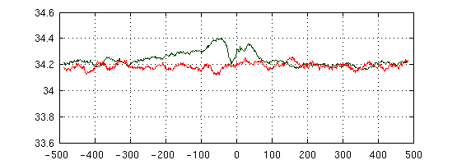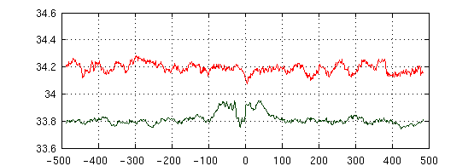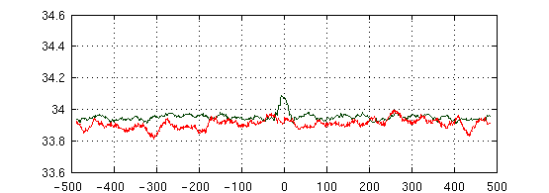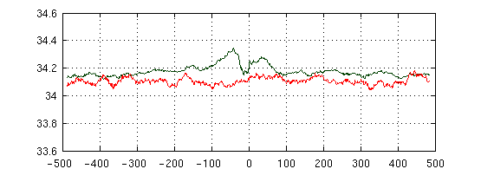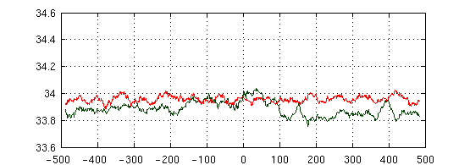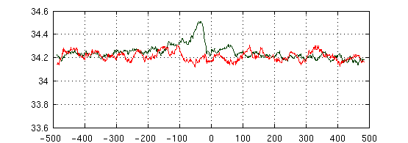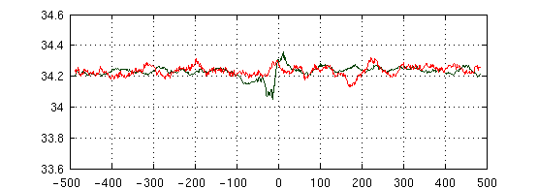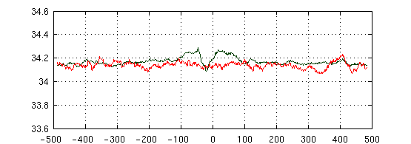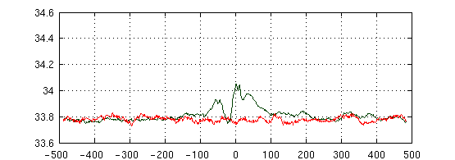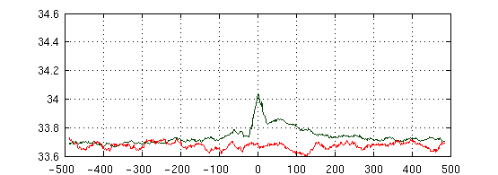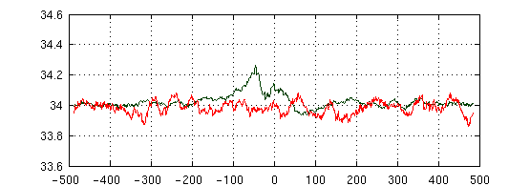

***Bacillus amyloliquefaciens***

***Chlamydia pneumonia CWL029***

***Escherichia coli***

***Halofrex volcanii***

***Helicobacter pylori***

***Methanolobus psychrophilus***

***Mycobacterium tuberculosis H37Rv***

***Pseudomonas aeruginosa PA14***

***Salmonella typhimurium***

***Streptomyces coelicolor A3***

***Synechocystis sp. PCC6803***

***Thermococcus kodakarensis***

**S2-18 (H-Rise)**

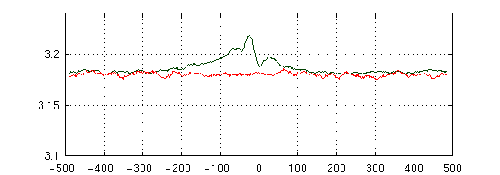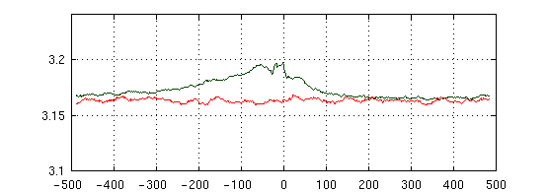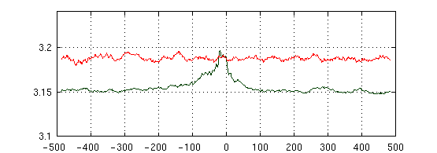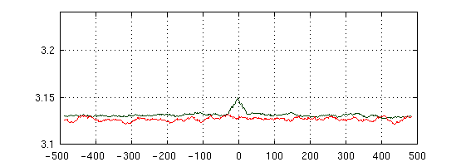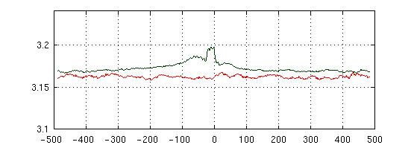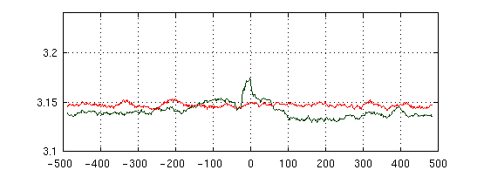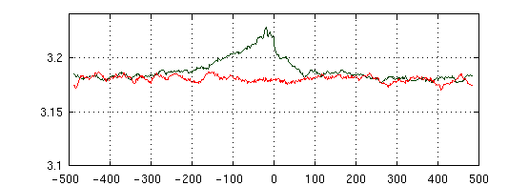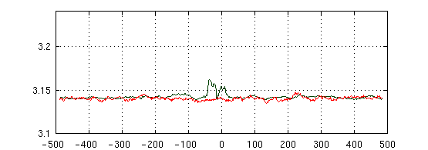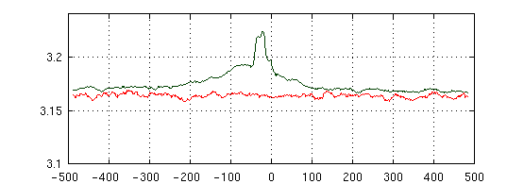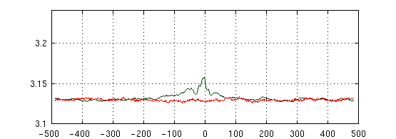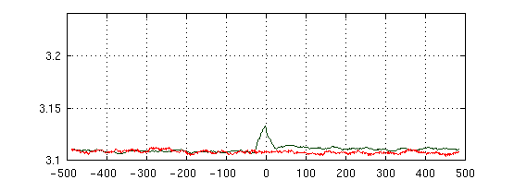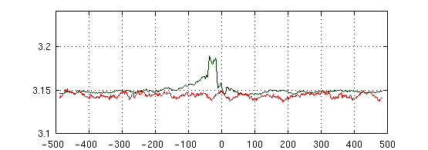

***Bacillus amyloliquefaciens***

***Chlamydia pneumonia CWL029***

***Escherichia coli***

***Halofrex volcanii***

***Helicobacter pylori***

***Methanolobus psychrophilus***

***Mycobacterium tuberculosis H37Rv***

***Pseudomonas aeruginosa PA14***

***Salmonella typhimurium***

***Streptomyces coelicolor A3***

***Synechocystis sp. PCC6803***

***Thermococcus kodakarensis***

**S2-19 (H-Twist)**

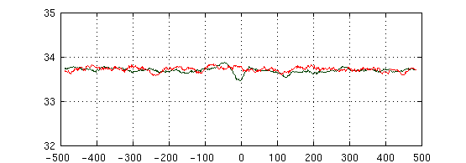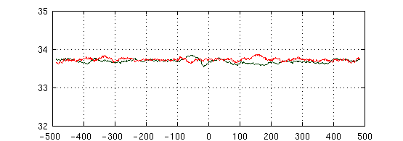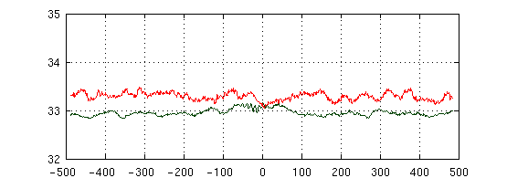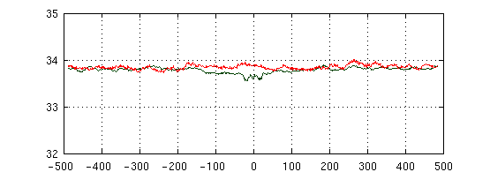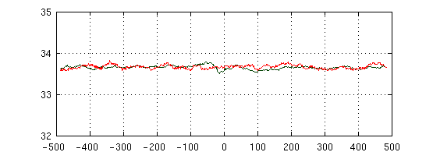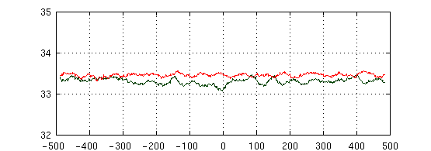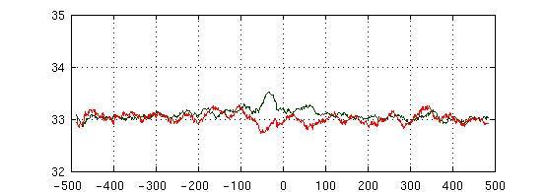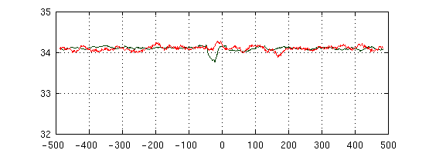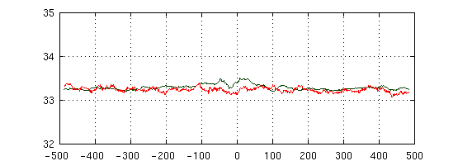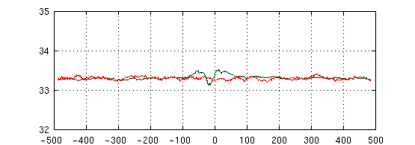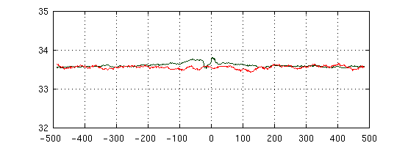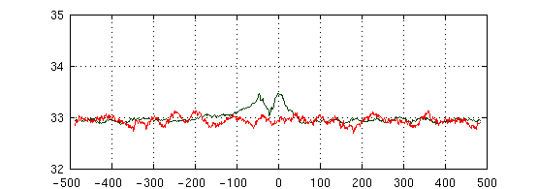

***Bacillus amyloliquefaciens***

***Chlamydia pneumonia CWL029***

***Escherichia coli***

***Halofrex volcanii***

***Helicobacter pylori***

***Methanolobus psychrophilus***

***Mycobacterium tuberculosis H37Rv***

***Pseudomonas aeruginosa PA14***

***Salmonella typhimurium***

***Streptomyces coelicolor A3***

***Synechocystis sp. PCC6803***

***Thermococcus kodakarensis***

**S2-20 (Alpha)**

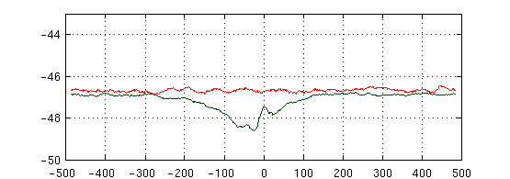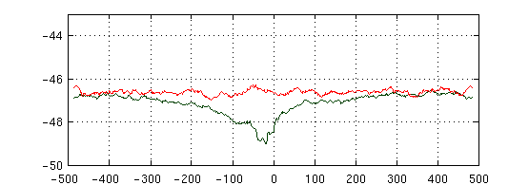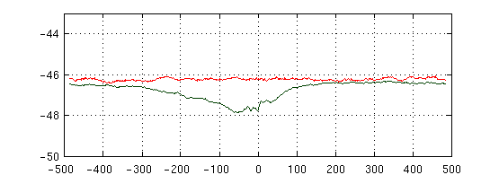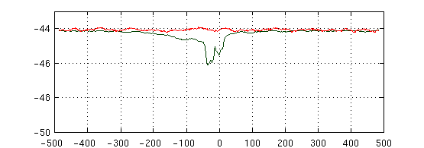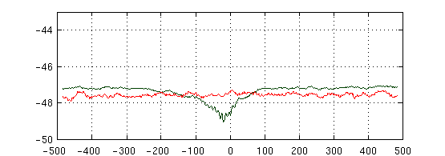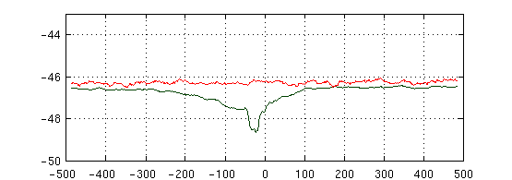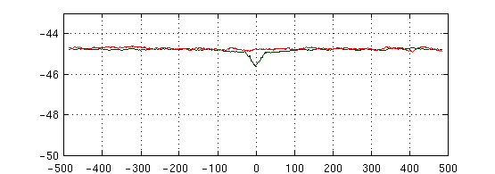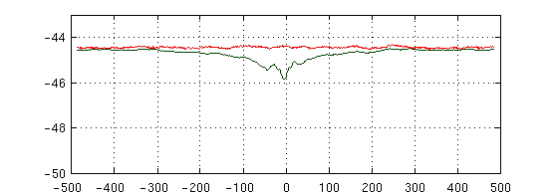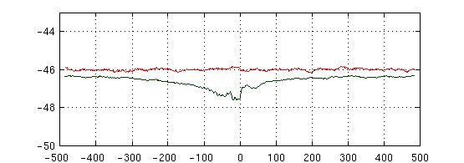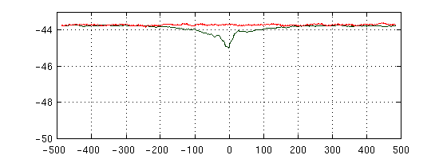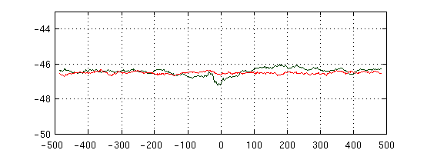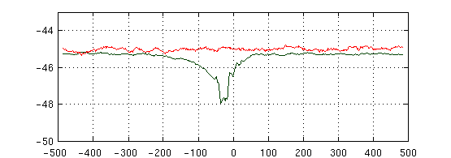

***Bacillus amyloliquefaciens***

***Chlamydia pneumonia CWL029***

***Escherichia coli***

***Halofrex volcanii***

***Helicobacter pylori***

***Methanolobus psychrophilus***

***Mycobacterium tuberculosis H37Rv***

***Pseudomonas aeruginosa PA14***

***Salmonella typhimurium***

***Streptomyces coelicolor A3***

***Synechocystis sp. PCC6803***

***Thermococcus kodakarensis***

**S2-21 (Beta)**

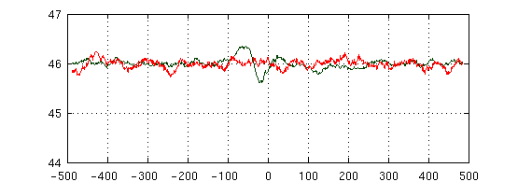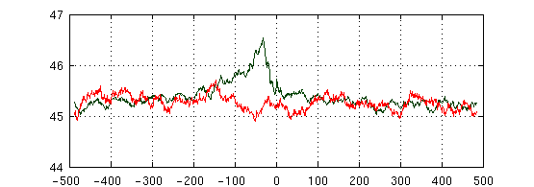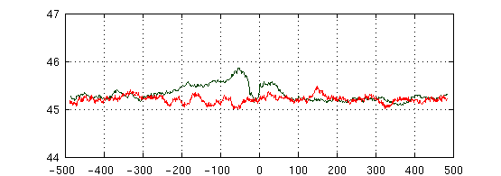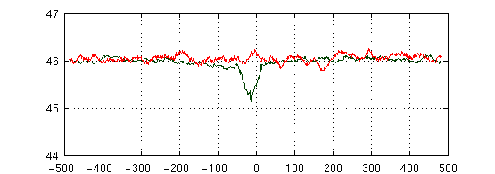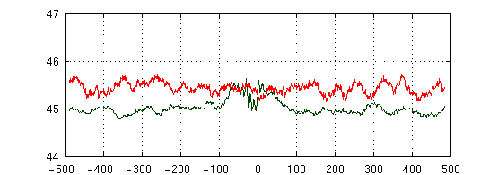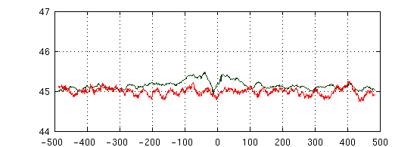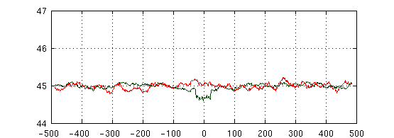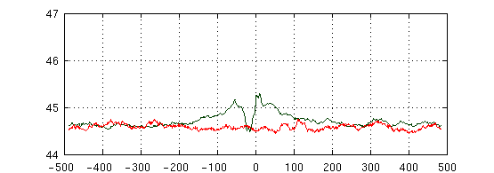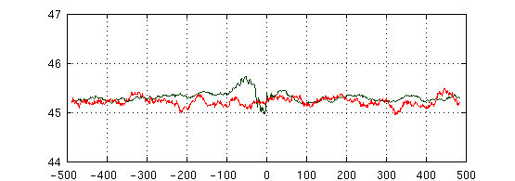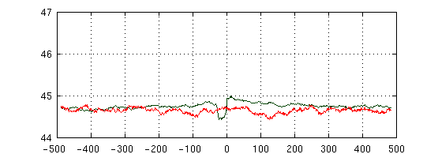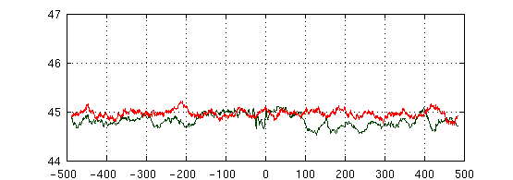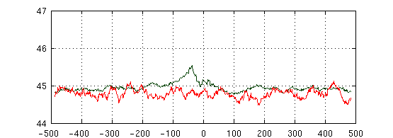

***Bacillus amyloliquefaciens***

***Chlamydia pneumonia CWL029***

***Escherichia coli***

***Halofrex volcanii***

***Helicobacter pylori***

***Methanolobus psychrophilus***

***Mycobacterium tuberculosis H37Rv***

***Pseudomonas aeruginosa PA14***

***Salmonella typhimurium***

***Streptomyces coelicolor A3***

***Synechocystis sp. PCC6803***

***Thermococcus kodakarensis***

**S2-22 (Gamma)**

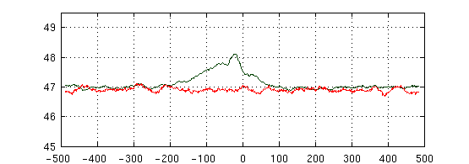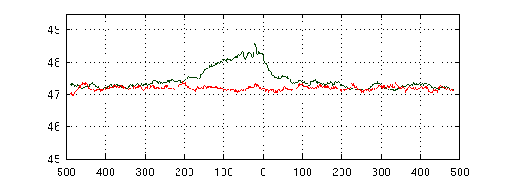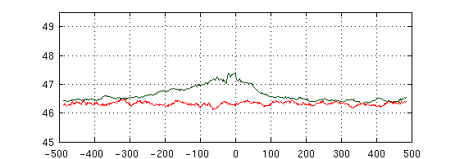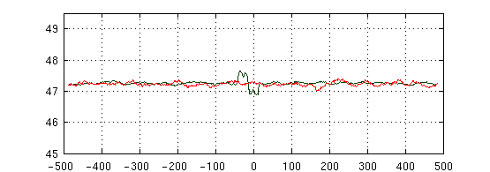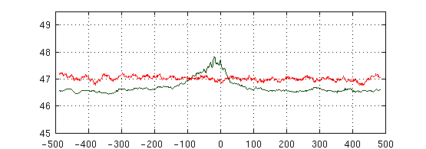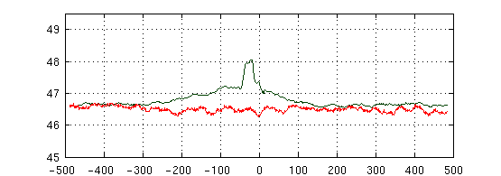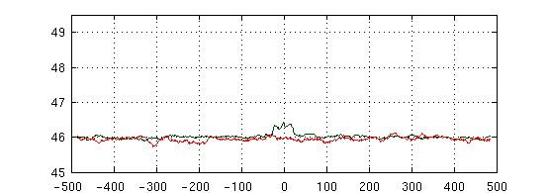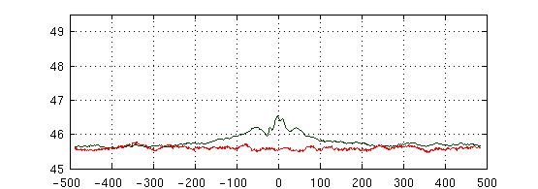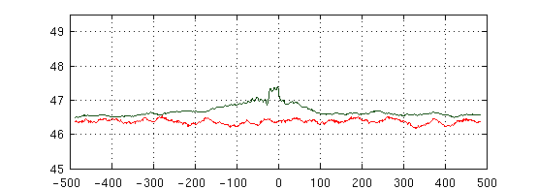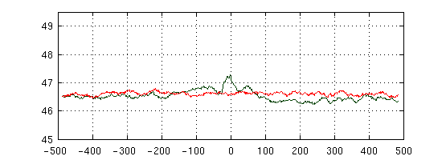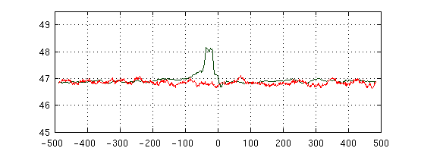

***Bacillus amyloliquefaciens***

***Chlamydia pneumonia CWL029***

***Escherichia coli***

***Halofrex volcanii***

***Helicobacter pylori***

***Methanolobus psychrophilus***

***Mycobacterium tuberculosis H37Rv***

***Pseudomonas aeruginosa PA14***

***Salmonella typhimurium***

***Streptomyces coelicolor A3***

***Synechocystis sp. PCC6803***

***Thermococcus kodakarensis***

**S2-23 (Delta)**

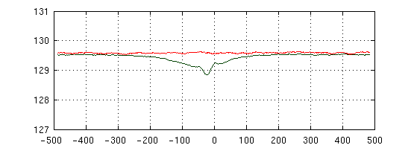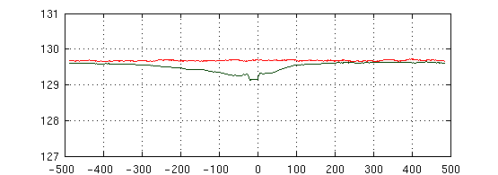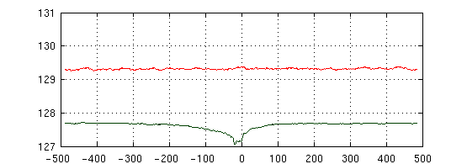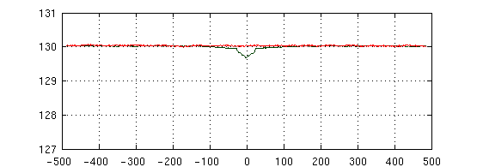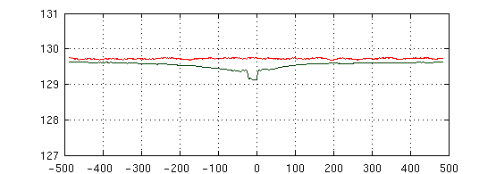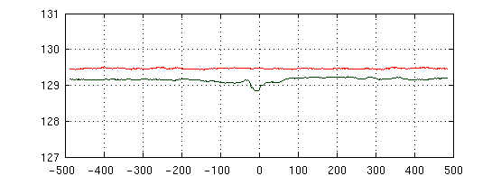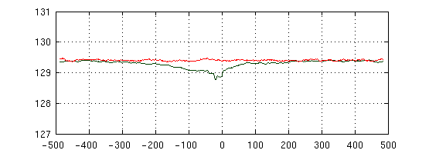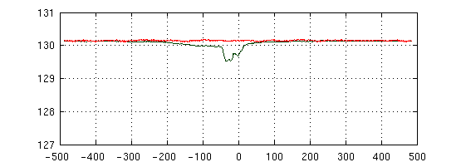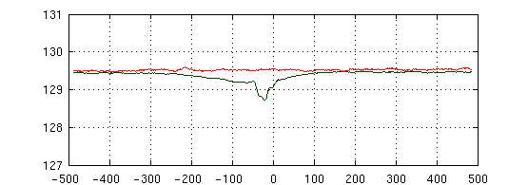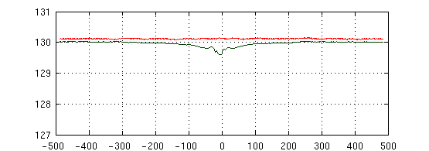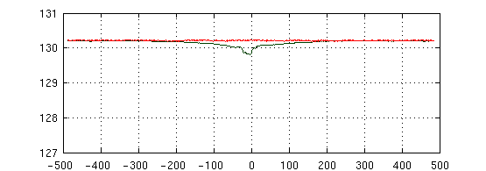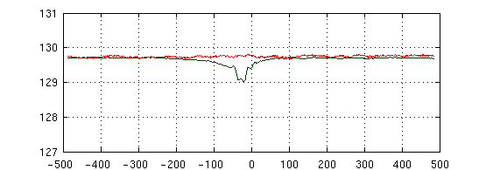

***Bacillus amyloliquefaciens***

***Chlamydia pneumonia CWL029***

***Escherichia coli***

***Halofrex volcanii***

***Helicobacter pylori***

***Methanolobus psychrophilus***

***Mycobacterium tuberculosis H37Rv***

***Pseudomonas aeruginosa PA14***

***Salmonella typhimurium***

***Streptomyces coelicolor A3***

***Synechocystis sp. PCC6803***

***Thermococcus kodakarensis***

**S2-24 (Epsilon)**

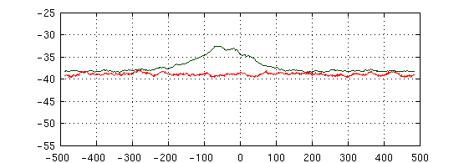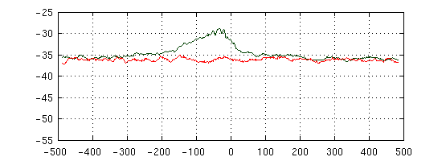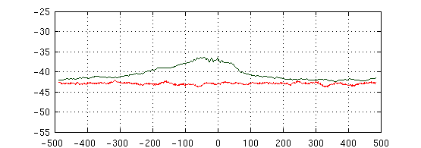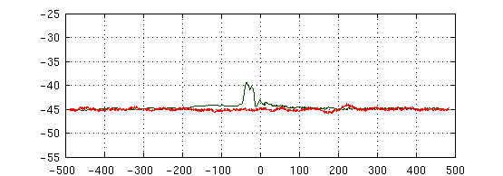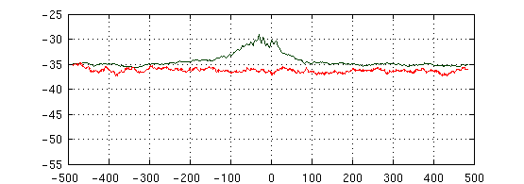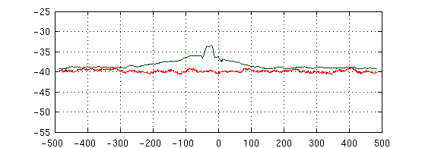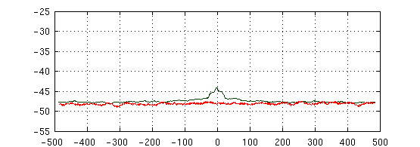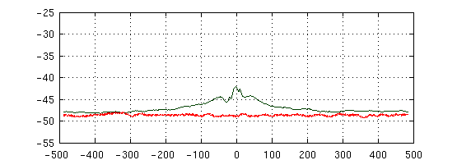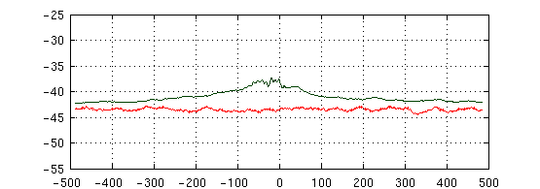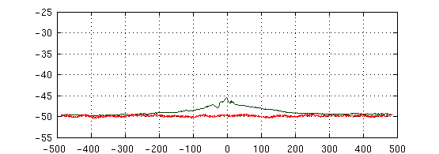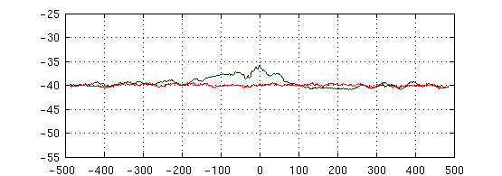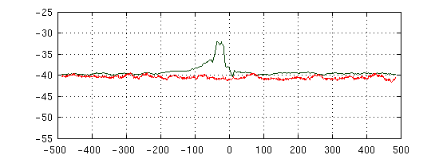

***Bacillus amyloliquefaciens***

***Chlamydia pneumonia CWL029***

***Escherichia coli***

***Halofrex volcanii***

***Helicobacter pylori***

***Methanolobus psychrophilus***

***Mycobacterium tuberculosis H37Rv***

***Pseudomonas aeruginosa PA14***

***Salmonella typhimurium***

***Streptomyces coelicolor A3***

***Synechocystis sp. PCC6803***

***Thermococcus kodakarensis***

**S2-25 (Zeta)**

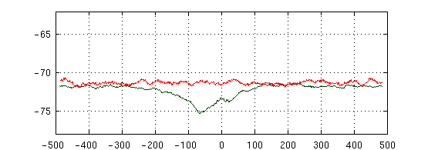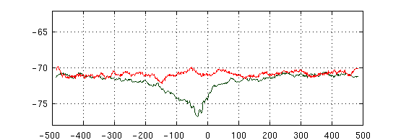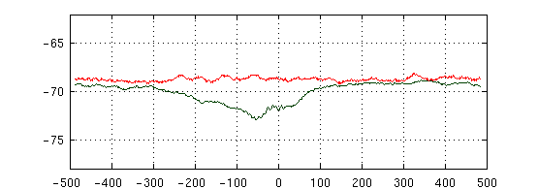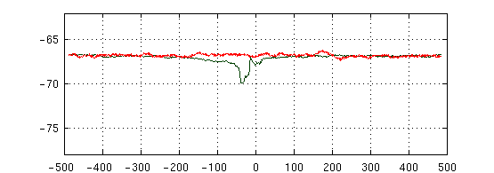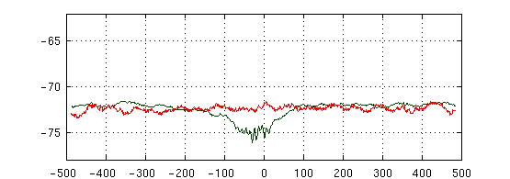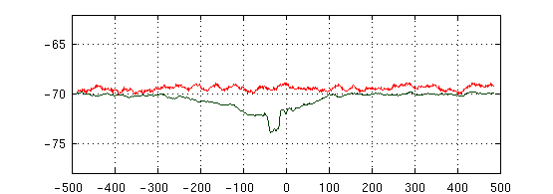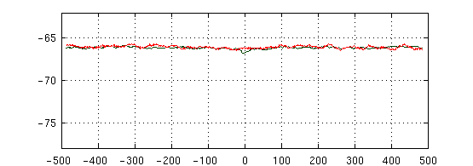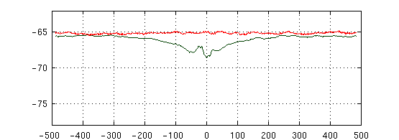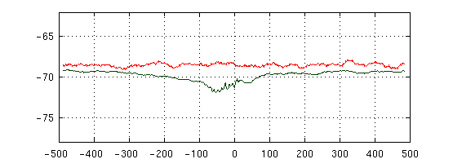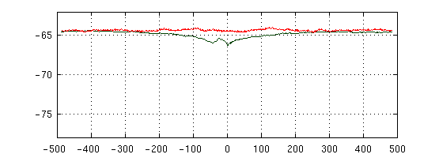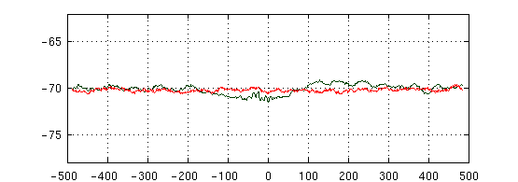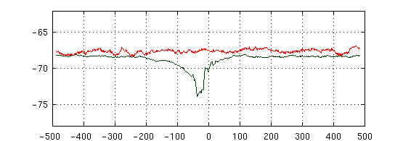

***Bacillus amyloliquefaciens***

***Chlamydia pneumonia CWL029***

***Escherichia coli***

***Halofrex volcanii***

***Helicobacter pylori***

***Methanolobus psychrophilus***

***Mycobacterium tuberculosis H37Rv***

***Pseudomonas aeruginosa PA14***

***Salmonella typhimurium***

***Streptomyces coelicolor A3***

***Synechocystis sp. PCC6803***

***Thermococcus kodakarensis***

**S1-26 (Chi)**

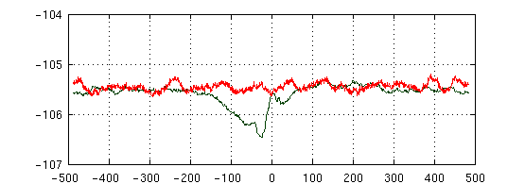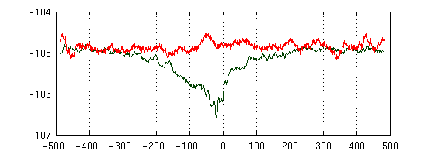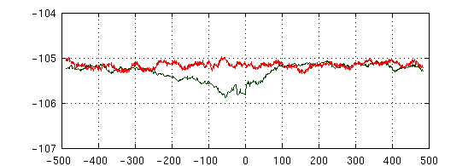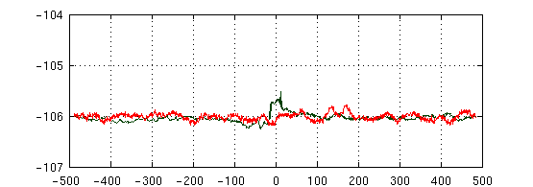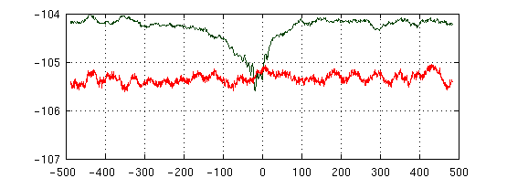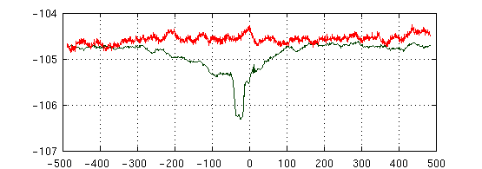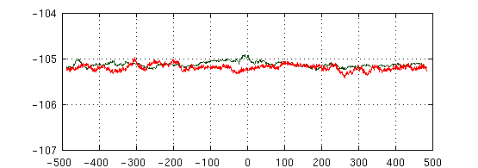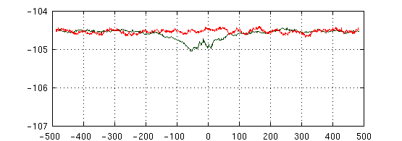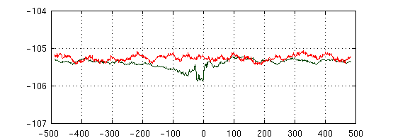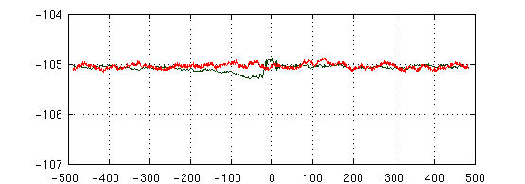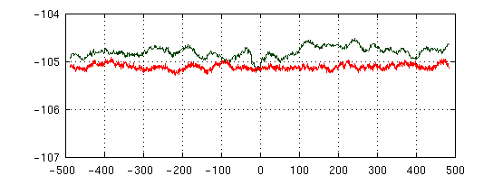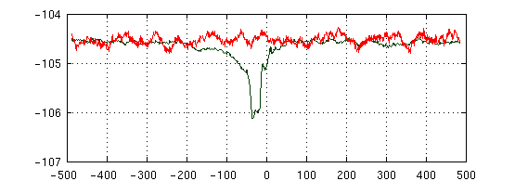

***Bacillus amyloliquefaciens***

***Chlamydia pneumonia CWL029***

***Escherichia coli***

***Halofrex volcanii***

***Helicobacter pylori***

***Methanolobus psychrophilus***

***Mycobacterium tuberculosis H37Rv***

***Pseudomonas aeruginosa PA14***

***Salmonella typhimurium***

***Streptomyces coelicolor A3***

***Synechocystis sp. PCC6803***

***Thermococcus kodakarensis***

**S2-27 (Phase)**

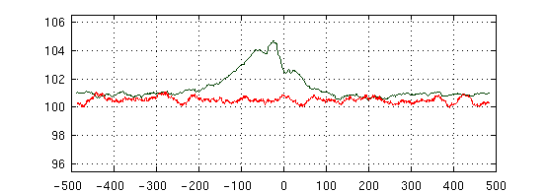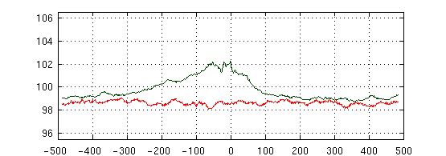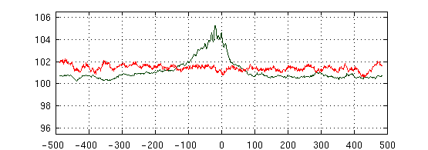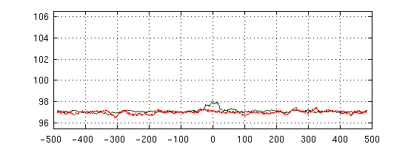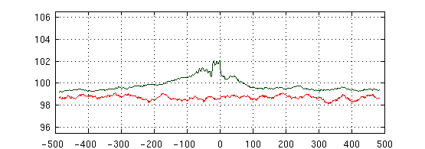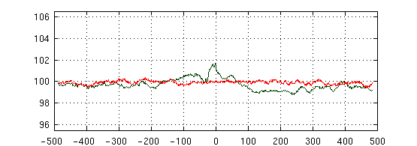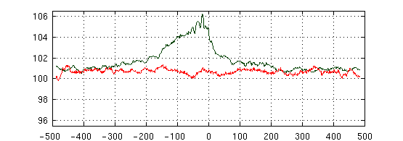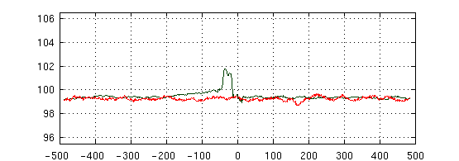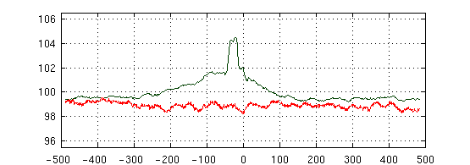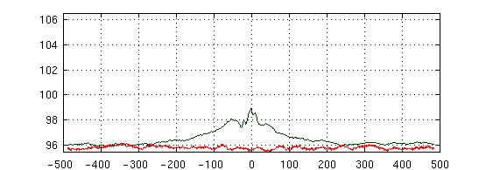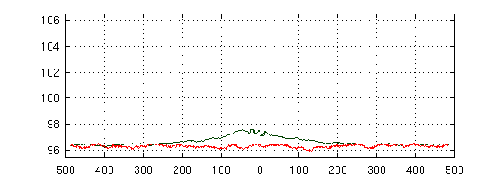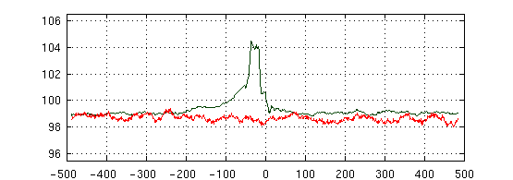

***Bacillus amyloliquefaciens***

***Chlamydia pneumonia CWL029***

***Escherichia coli***

***Halofrex volcanii***

***Helicobacter pylori***

***Methanolobus psychrophilus***

***Mycobacterium tuberculosis H37Rv***

***Pseudomonas aeruginosa PA14***

***Salmonella typhimurium***

***Streptomyces coelicolor A3***

***Synechocystis sp. PCC6803***

***Thermococcus kodakarensis***

**S2-28 (Amplitude)**

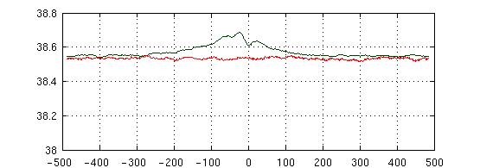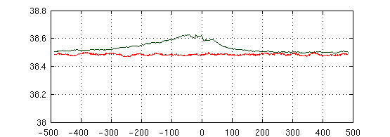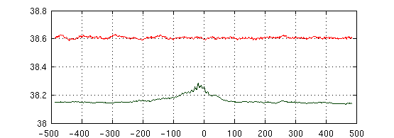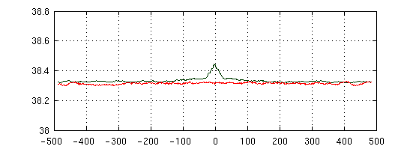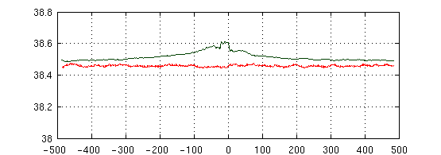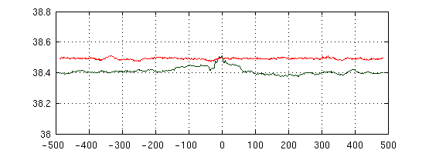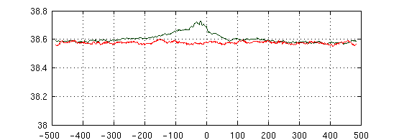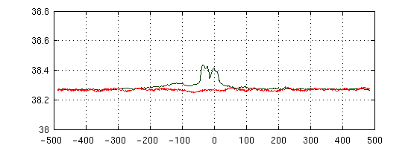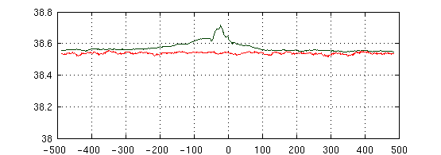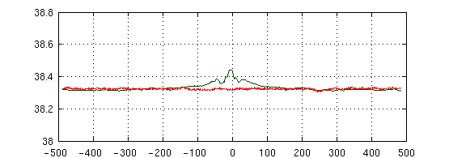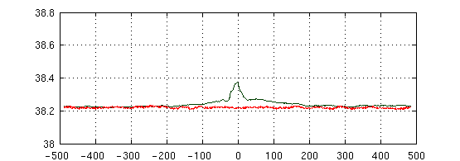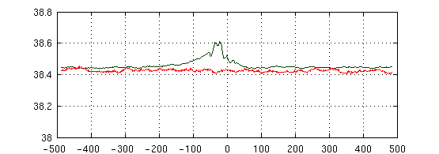

***Bacillus amyloliquefaciens***

***Chlamydia pneumonia CWL029***

***Escherichia coli***

***Halofrex volcanii***

***Helicobacter pylori***

***Methanolobus psychrophilus***

***Mycobacterium tuberculosis H37Rv***

***Pseudomonas aeruginosa PA14***

***Salmonella typhimurium***

***Streptomyces coelicolor A3***

***Synechocystis sp. PCC6803***

***Thermococcus kodakarensis***

**S2-29 (Hydrogen Bond Energy)**

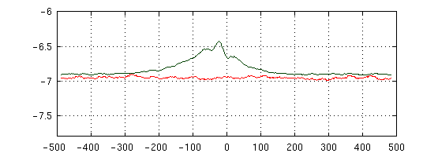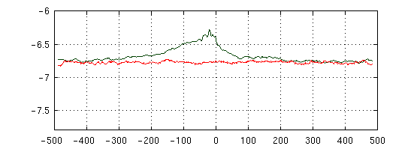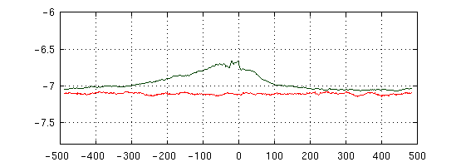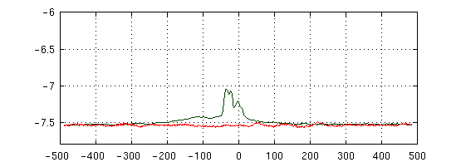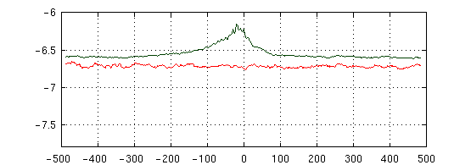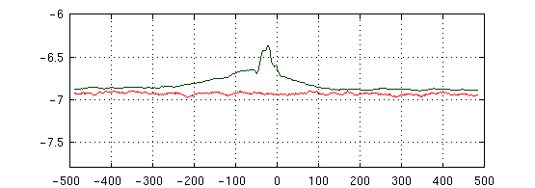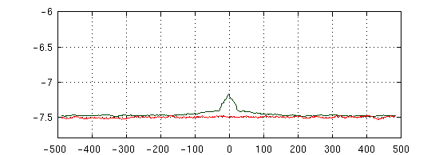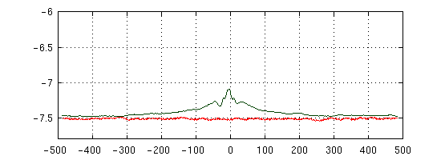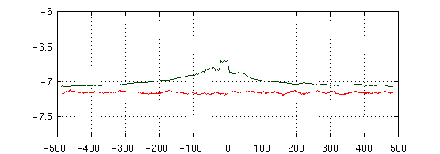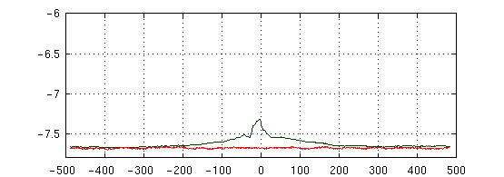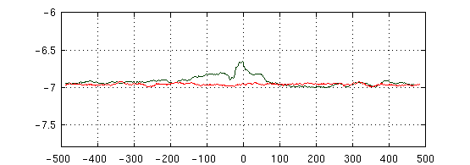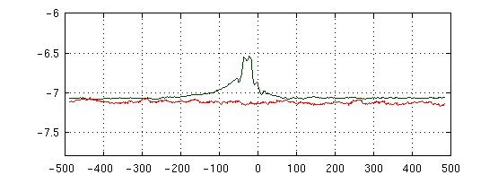

***Bacillus amyloliquefaciens***

***Chlamydia pneumonia CWL029***

***Escherichia coli***

***Halofrex volcanii***

***Helicobacter pylori***

***Methanolobus psychrophilus***

***Mycobacterium tuberculosis H37Rv***

***Pseudomonas aeruginosa PA14***

***Salmonella typhimurium***

***Streptomyces coelicolor A3***

***Synechocystis sp. PCC6803***

***Thermococcus kodakarensis***

**S2-30 (Stacking Energy)**

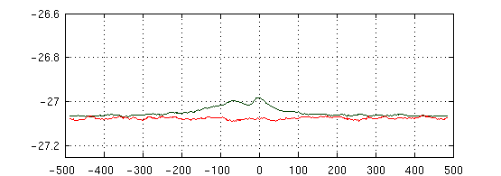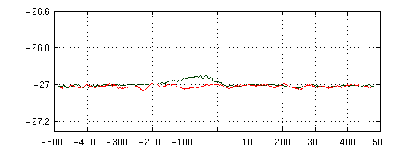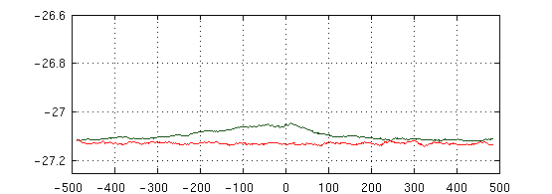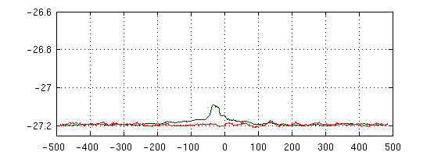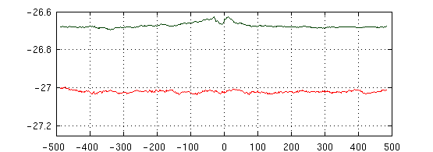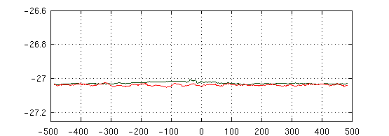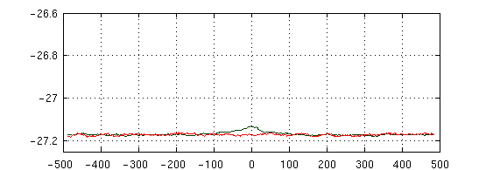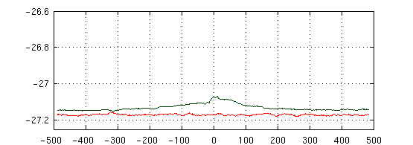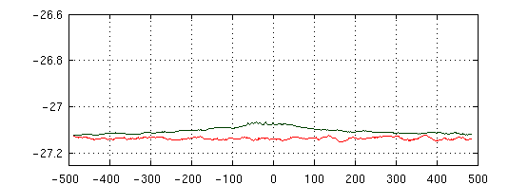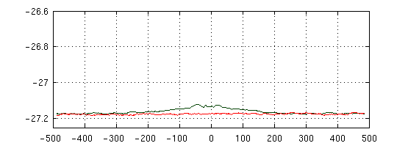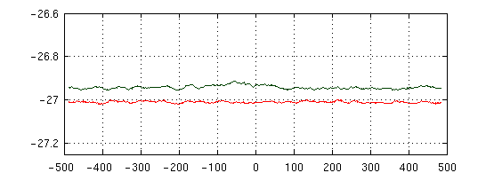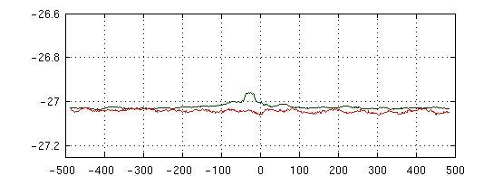

***Bacillus amyloliquefaciens***

***Chlamydia pneumonia CWL029***

***Escherichia coli***

***Halofrex volcanii***

***Helicobacter pylori***

***Methanolobus psychrophilus***

***Mycobacterium tuberculosis H37Rv***

***Pseudomonas aeruginosa PA14***

***Salmonella typhimurium***

***Streptomyces coelicolor A3***

***Synechocystis sp. PCC6803***

***Thermococcus kodakarensis***

**S2-31 (Solvation Energy)**

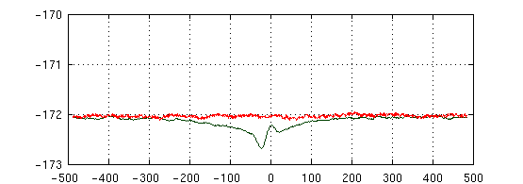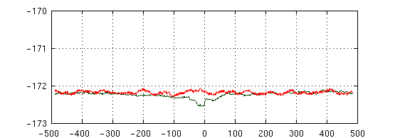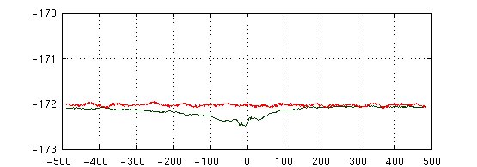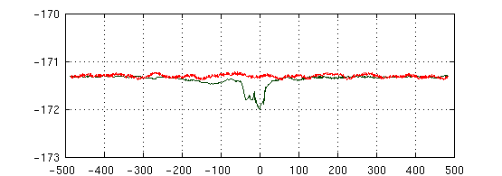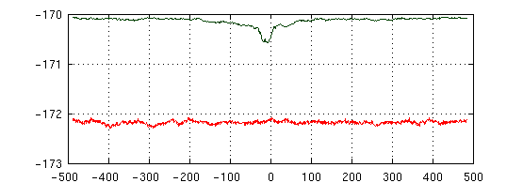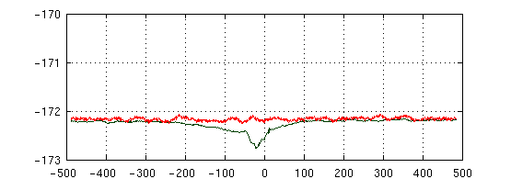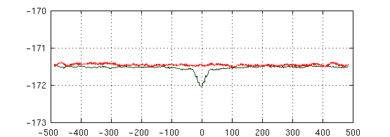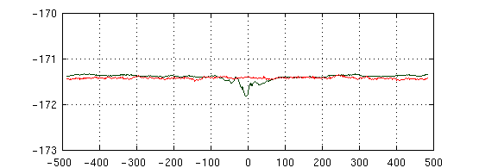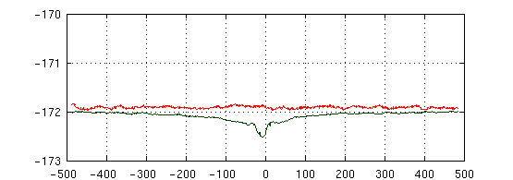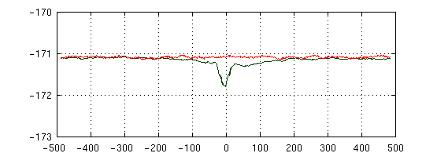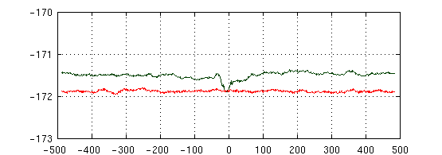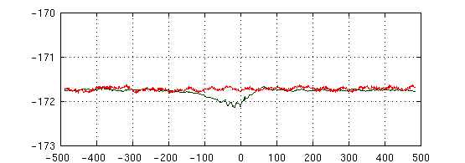

a.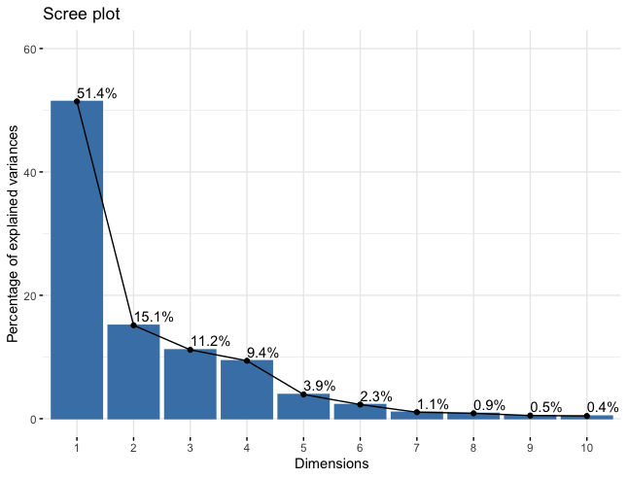 b. 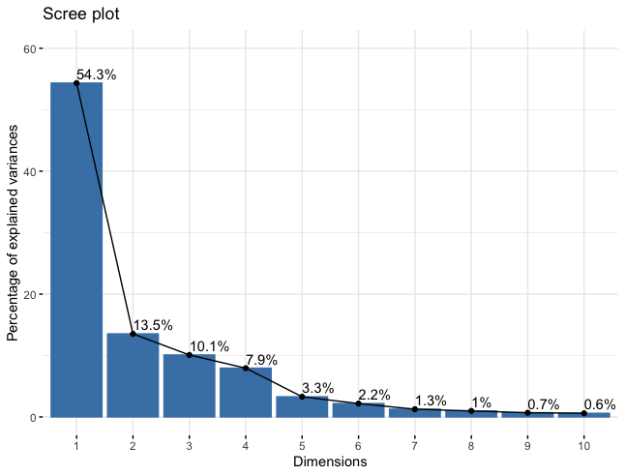

c.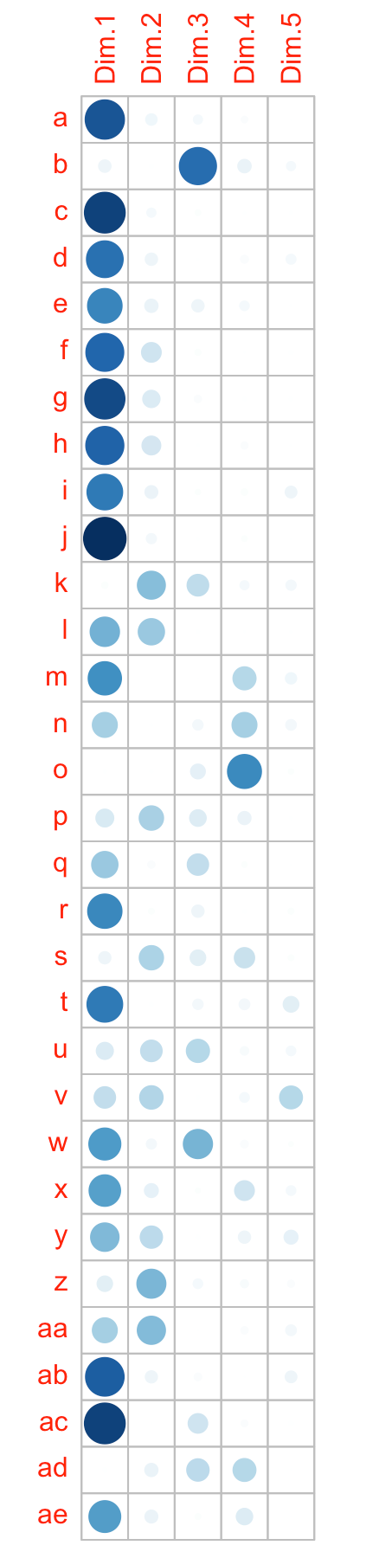 d.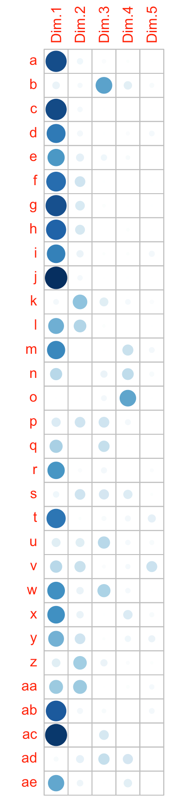

**Supplementary Figure S3.**  a &b: Histogram showing percentage of explained variance in data for the first ten PCAs for continuous stretch of 40 and 80 bp just upstream of TSS., c & d: contribution of each of the 31parameters in the total variance of each of the first five PCAs.

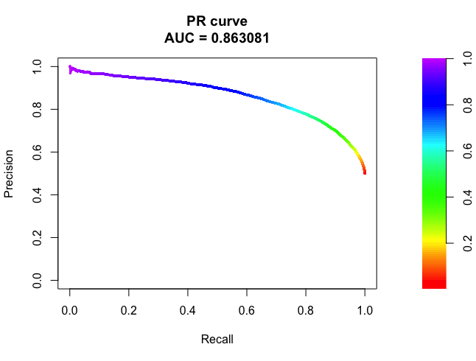

**Supplementary figure S4**: Precision-recall curve obtained when SEProm run over data of all the

twelve organisms.